Using Partial Rubber Motors.
You will have come across the advice to use a partial motor at some time – this simply means using a motor that is 1/3, 1/4 or half the weight of your desired full motor.
Why do this? There are several very good reasons:- 1) it uses less of your precious rubber, 2) Flights are shorter enabling faster trimming/testing, 3) You can prepare for full motor flights in a higher venue.
Getting started.
- First you have to decide on the weight of your full motor. Easy if this is defined by the model class rules eg. F1D, F1M but otherwise you have to make your own decision, 70 to 90%of the finished airframe weight is a good starting point though. An F1L of 1.2gm will fly happily on 0.8 to 1.0gm of rubber.
- Decide on the partial motor you will fly on. Once again this may be predetermined eg F1D Team Trials currently specify ¼ motors whilst the F1D Nationals at Boulby (50’ ceiling) use 1/3 motors.
At the moment I mainly fly 1/3 motors on non F1D models because if I stay a couple of feet below the typical 22’ roof then a full motor will take me to the ceiling at Boulby. If I’m setting up a model for Belgrade with a ceiling height of 90’ then I’ll mostly fly ¼ motors.

OK, let’s make a 1/3 F1L motor spacer where the full motor will weigh 1.0gm and the distance from the rear of the prop. hook to the front of the rear hook is 10.5”.
So this means the spacer length will be 2/3 x 10.5” = 7” and it must weight 2/3 x 1.0 gm or 0.67gm. Make sure that its CG is in the middle.
The 1/3 motor will weigh 333mg and it’s length will depend on the gm/metre weight of the rubber you’ve elected to fly on. For an F1L this will typically be in the range 1.35g to 1.50g per metre.
The Spacer.
Take a look at the photo. The top all wire one (.025”) is a 1/3 F1L spacer and these are quickest to make. They are not my favourite because they are easily lost on the floor when a motor breaks and they fly off the torque meter into deep space and also they are perhaps less easy to grip when loading the motor onto the model. 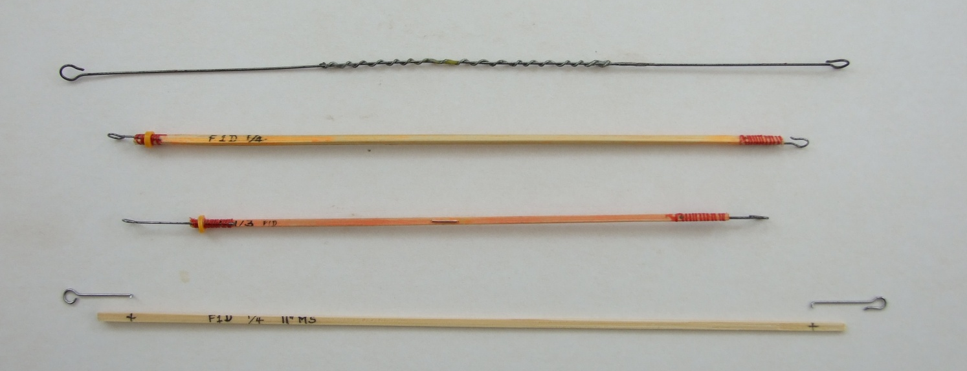
The next two are F1D ¼ and 1/3 spacers made from bamboo skewers (but can be hard balsa, bass wood etc) with .023” ‘ish wire ends, note the highlighter pen colouring! The skewer will require razor planning/sanding down to weight.
The last is a new, longer, F1D spacer to suit a longer motor stick model and shows the wire ends before attaching with thread binding and superglue.
If the spacer is overweight sand it down a bit and if underweight wrap it with fuse wire at the CG and superglue.
Using the Spacer.
The partial motor is made up with 1 O-ring, the knotted end is hooked onto the spacer and the spacer hooked onto the torque meter. The O-ring hooks onto the winder.
When wound you detach the O-ring from the winder hook and put the O-ring onto the prop hook, then holding the prop shaft/rear of prop bearing attach the spacer to the rear hook.
travel toothbrush case makes a handy container. 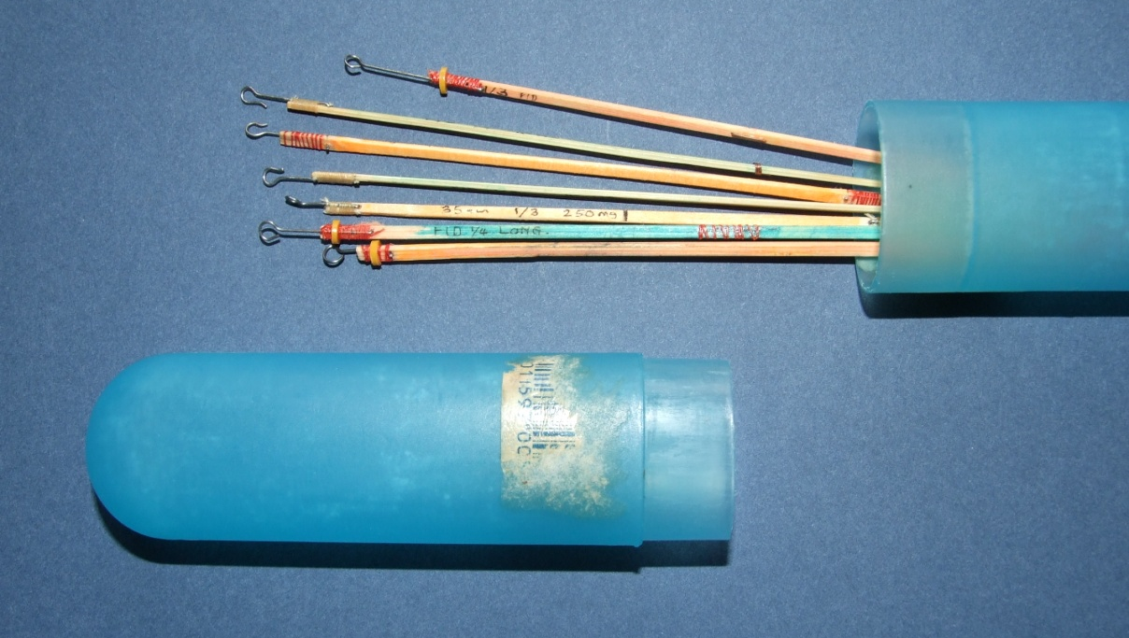
If you have unrestricted models of different weights that require different motor weights then you need to have separate spacers of varying weights.

Tony Hebb Jan 2013

