Making a simple Torque Meter
One of the first bits of kit you need for indoor flying is a winding stooge, a torque meter and a winder – plus a clamp to attach it to your table.
My first one I copied from the INAV site. It’s simple and effective, especially for thicker motors. My Gymminnie Cricket flies on .090 rubber and I used a 15:1 yellow KP winder (10:1 is better).
There were some problems – it’s not adjustable for different length motors such as you need to fly different classes, the wire is exposed, not a serious flaw and easily remedied, thick motors create a lot of torque so full dial deflection of about 100 gm.cm required. The one on the INAV site is in oz.inches – which is what I happily used at the time!! By comparison an F1L will use a ¼ (or much less) of this launch torque.
The next requirement I had was in fact for an F1L (You’ll find that F1Ds use pretty much the same size rubber ) and therefore a torque range of 0 - 50 gm.cm was good. This time I had a few examples to copy from so I mounted the torque wire in a tube and made a base slider to allow it to be mounted at different points (matching the hook to hook distances of the F1L, F1D, F1R and MS) from the winder hook.
It worked OK but there were still more problems, this time the meter was a bit sticky especially at low torque; the dial was a bit on the small side – I hadn't noticed before but when winding full motors in Belgrade you end up some distance from the dial face – OK bad eyes too! Furthermore it was sensitive to the angle of winding, so I had to bend forward to keep things level.
OK! I was at a bit of a loose end before starting our hols to New Zealand earlier in the year so thought a better mousetrap must be possible. Now I can saw and grind bits of metal and wood, use epoxy and a soldering iron- but I am not an engineer.
I had a good look at what seemed to be working for the other guys and came up with this.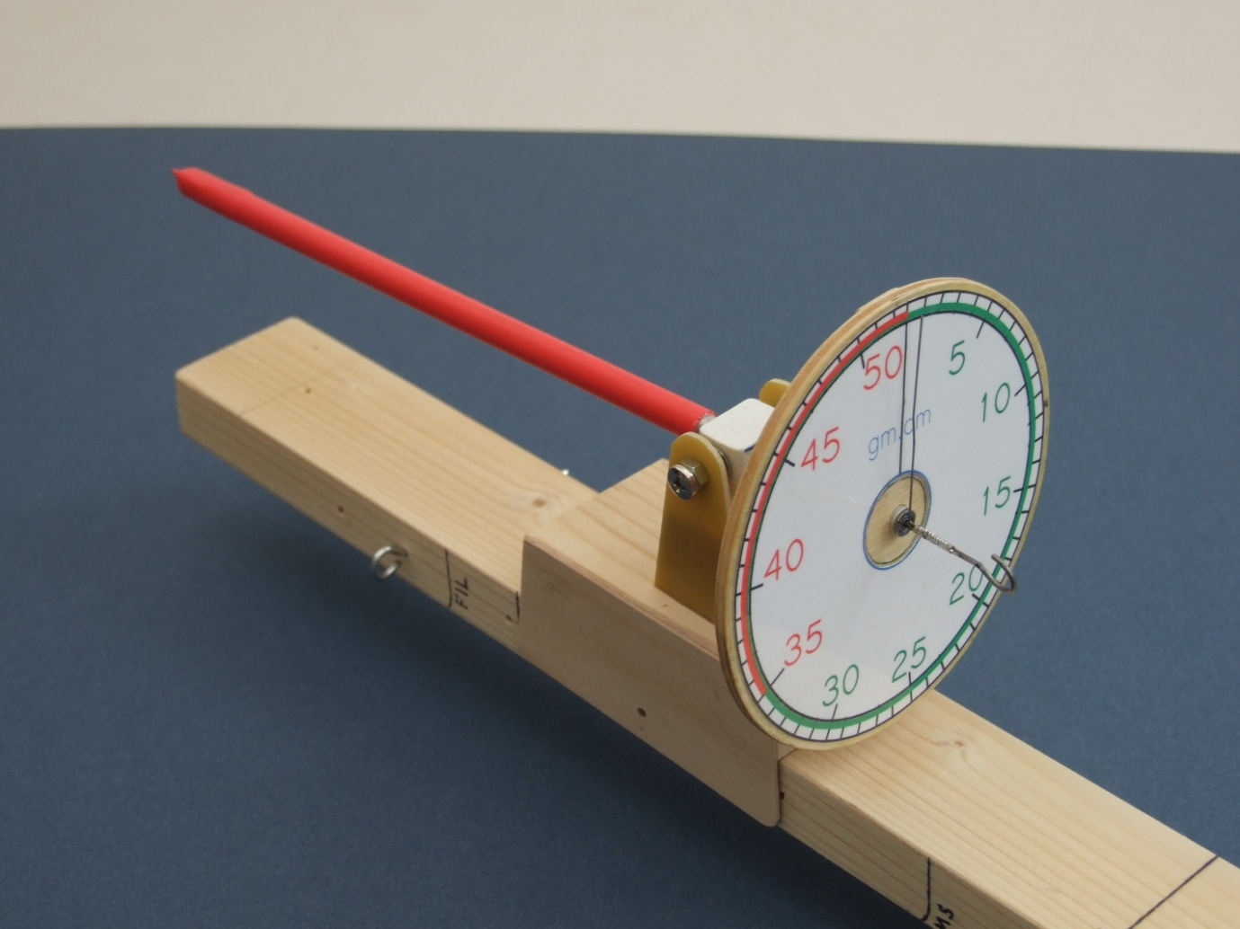
First of all to take care of the stickiness I used a small bearing from Arc Euro – its the smallest imperial size they do, £3.50 +p&p. It has a small front flange which allows you to sparingly epoxy it into the front of your ¼” torque tube – this is best from brass, though I used aluminium which proved too light and soft – so much for a better mousetrap!
A 4” dial seemed about the right size so I made this from 1/8” ply, the dial face I drew up on CAD STD (download a free copy – very useful) – I have a few spare let me know if you’d like one it reads 0 – 53 gm.cm.
Finally I created a seesaw type pivot from some epoxy glass sheet and a couple of 4mm bolts. The central pivot block was made from a plastic curtain track fitting but hardwood or a hex nut would do the job I’m sure.
The base is a piece of 21” long 43x20mm pine and the slider is from the same material with 1/16” ply sides, you need to sand the base sides a little to give sliding clearance. Thanks to John Shaw for this idea. You can see what things look like in the diagrams and photos below.
The red covering on the ali tube is heat shrink – I needed the extra weight to balance the tube at a sensible point! Aluminium too light!!
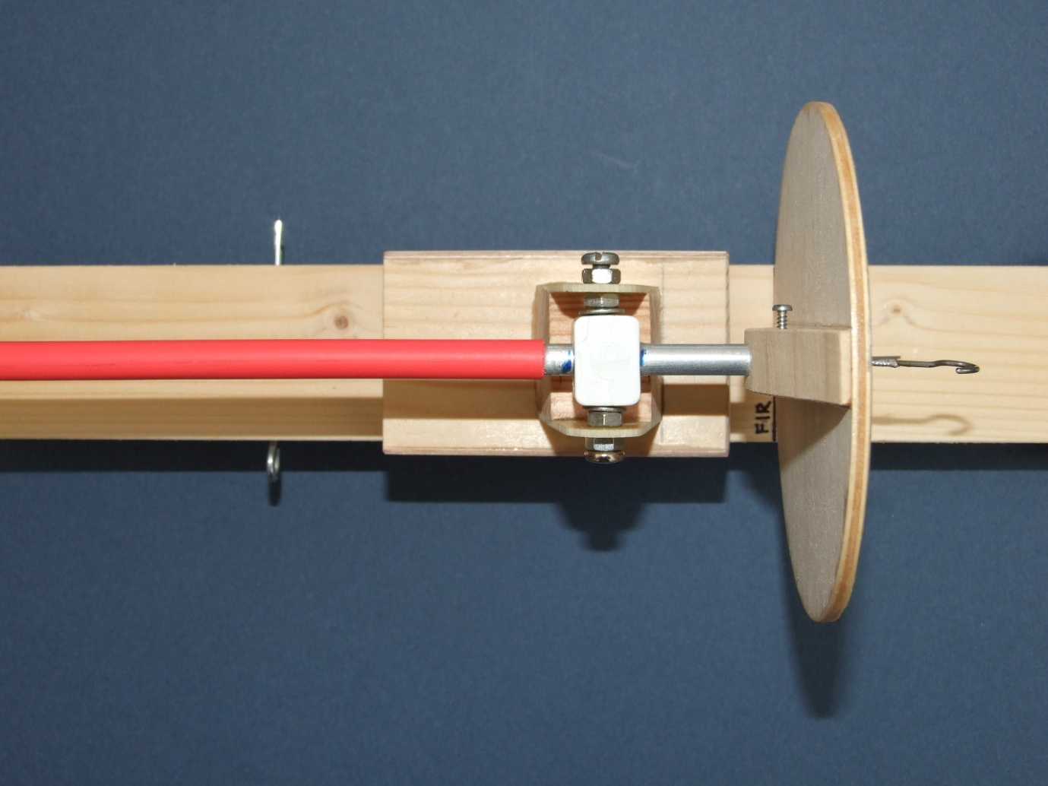
The active torque wire is a piece of .015” guitar string ( Try Stringbusters plain steel strings in many sizes from .007 up) or piano wire 8.5” long. There is a great little program on the INAV site that allows you to input your desired full dial deflection and wire thickness and it tells you the required length of wire - this works pretty accurately too. It works in ounce.inches so you’ll need to convert to gm.cm. 1 oz.in = 72.6 gm.cm.
Solder the torque wire to a flat “w” clip (from .020” ‘ish wire) at one end and to a folded back piece of wire that will fit nicely into the front bearing – about .050”. Use slow set epoxy to fix the clip at one end and the bearing at the other – remember to use it sparingly around the bearing.
Before bending the motor hook make up the pivot block and slide it onto the tube, also the dial face – I made mine a push fit with a fixing screw so I could zeroise the meter if necessary. Thanks to Pete Ing for this idea. Bind and solder the indicator needle to the shaft and then form a simple hook.
Once the slider base is made – I just epoxied mine together – then you need to mount the torque meter onto it. Assemble so that the unit just balances, mark this point and then epoxy the pivot block in place.
Finally mount your winder onto the base and then mark where the slider unit needs to be for your different models. Drill clearance holes at each position and use a 1/16” wire pin to retain. Its useful to clearly labels these locations, F1L and F1D for example are quite similar.
My meter deflection came out spot on to the INAV prediction, so that was nice.
To calibrate you can use 2 methods.
- Hang a 10 gm weight at 2cm from the centre line of the of the shaft on the indicator needle – a bit of sticky glue helps keep the suspending thread correctly located. Carefully pick up the Torque Meter whilst rotating to keep the needle horizontal and the weight in place, mark where the needle reaches on the dial. That’s 20gm.cm, measure the angle, divide by 20 and that gives the angle you need to mark off the units on your dial face. CAD STD lets you draw lines at any angle, telling you the current angle of the drawn line as you go, neat.

- Engage the hook of your TM with another of known accuracy. Rotate until 20 gm.cm indicated and mark that point on your dial face.

In best Blue Peter fashion you can use some clear sticky back plastic to cover the printed dial face and then stick it on with contact adhesive.
So....... no engineering really, but hopefully a perfectly good torque meter this time, we’ll see.

Tony Hebb May 2012-05-04
I’ve used the meter throughout the Summer – including the oppressive heat in Belgrade - and it’s been absolutely fine, the front bearing glue joint did come loose so I stuck it back with a touch more epoxy – be careful though! I’d still use my old meter to wind a Pennyplane or GC (or F1M ) motor to avoid overloading the torque wire
November 2012

