Setting up a Treger VP Hub for F1D models. Tony Hebb. Nov 2014

1.0 Introduction.
In general terms a Variable Pitch (VP) Hub enables you to fly for longer in low ceiling sites.
It does this by changing the pitch of the propeller from very high to low depending on the torque level of the rubber motor as it unwinds. The high pitch at the start prevents the model from climbing too fast under the high initial torque of the motor. A spring and screw adjuster allow you to vary the timing of the change.

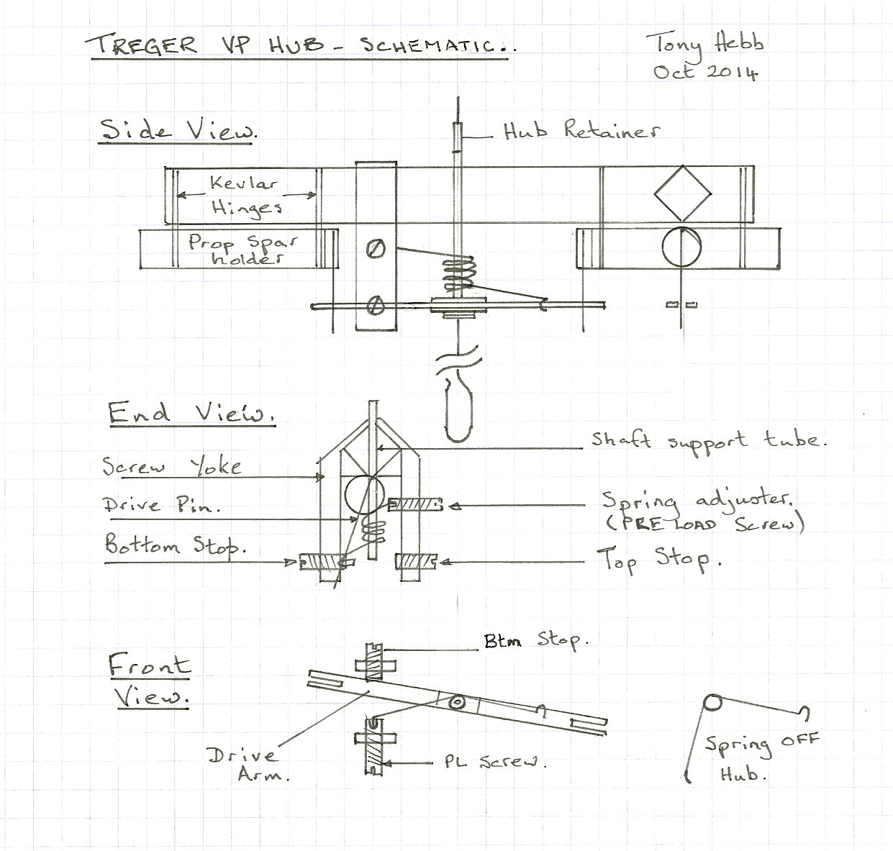
1.1 Bottom Stop.
This is the screw adjuster that varies the low pitch of the propeller. You will find that the Drive Arm will be pressed against this stop when the hub is at rest with no turns on the motor. Initially set the screw to allow 1 – 1 ½ turns from the fully screwed in point – this will give you several degrees of movement in each direction to adjust the prop. bottom pitch. At rest you will attach the propeller blades into the hub at typically 28” pitch (which is the same as setting the blades at 32 degrees at 7” radius).
To increase the bottom (aka. Base) pitch turn the screw clockwise – ¼ turn at a time is about 1 degree – to reduce pitch turn anti-clockwise.
1.2 Top Stop.
This is the screw that allows you to change the high pitch setting of the propeller. If you hold the prop. hub gently at the front and rotate the prop hook clockwise you will see the drive arm and prop. blades move until it rests against this stop. About 20 degrees of movement is likely in low ceiling sites - this reduces as the ceiling height increases.
As for the bottom stop screw, the top stop screw will change the angle of blade movement by about 1 degree per ¼ turn, screw it in to reduce high pitch and unscrew it to increase pitch.
Here’s a way to roughly set this up.
Tack glue a strip of balsa about .030” square across the back of one blade, parallel to the centre rib. Draw a line across a sheet of paper and mark a point on it. Again, holding the hub lightly at the front, line up the balsa strip with your drawn line, rotate the hub shaft and mark on the paper the angle of movement. Repeat this a few times until you are happy with consistency. Measure the angle, change the Top Stop screw until you are getting about 20 degrees of movement.
Finally remove the tack glued strip with acetone.
1.3 Pre Load screw.
This screw is longer than the Top and Bottom stop screw as it is likely that more range of movement will be required. One end of the pre load spring is inserted in a hole in the inboard end of the screw, the other engages on the drive arm and at rest presses it against the bottom stop.
By screwing in the Pre Load screw you will bring forward the point at which the propeller starts to change from high pitch to low pitch, unscrewing delays this point.
1.4 Spring.
The standard Treger hub comes with a spring made from 008” steel wire, normally of 3.5 turns.
The fully wound motor will keep the drive arm pressed against the Top Stop (high pitch) until the motor torque drops below the high torque setting of the spring, perhaps 12 - 14gm.cm. At this point the prop. blades start to reduce pitch until the spring can push the drive arm against the Bottom Stop – normally around 6 -7 gm.cm – where it remains until the model lands.
1.5 Drive arm.
This thin carbon fibre lever moves from top stop to bottom stop as the pre load spring reacts to the reducing torque from the motor. Drive pins are engaged in its slotted ends through which the angle of the prop. blades are changed in their hinged sleeves.
It is important that the drive arm cannot move fore and aft on the prop. shaft, the hub retainer must be firmly glued in place so that the drive arm is centred on the top and bottom stop screws, otherwise it will slip off the top stop screw under high launch torque.

2.0 Basic VP Hub set up.
2.1 Equipment
Before you can successfully set up a VP prop, the most important piece of equipment is a reliable torque meter which will not stick or jam anywhere, particularly under tension load. See Section 3.2 for notes on accurate torque meter calibration.
It will always be good if you can enlist the help of an experienced flyer for the initial stages of VP set up, but if you can’t......
Your Prop needs to be roughly set up for base and high pitch as a starting point, as described above in Sections 1.1 to 1.4.
Your model also needs to be in good flight trim, this can be achieved through glide testing or flights with a known Fixed Pitch propeller.
2.2 Setting Top Pitch.
First check model on 10 gm.cm launch to make sure all OK for a higher torque flight.
Then mount the new VP prop.
Initially put a standard test wind on a 165mg 1.30gm/m (New Rules 3/8 + 250mg Spacer suggested) motor for each test flight. ie. wind to 35gm.cm and back off to 25gm.cm, note the total turns on and back off turns.
I suggest cycling 2 or 3 motors for test flying then they can have a rest between flights. Different coloured O-rings help keep track of things.
For the time being forget about overall flight times.
If the model is very reluctant to climb on 20 gm.cm or more torque, the prop maximum pitch is too high. Decrease by screwing in the top stop by 1/2 turn and try again.
On successive flights gradually increase the top pitch until the model will not get away without mushing, then decrease until it gets away cleanly. If your flying site is a hot, potentially turbulent venue then a little less top pitch is desirable otherwise the model will be prone to stall at low level and this results in an unpredictable climb.
You are looking for a climb to about 2 feet below ceiling height in 2 or 3 minutes. If it climbs too fast and you are sure that the model will carry no more pitch then increase stick bow. If it flies too flat then try decreasing stick bow. As a guide my model will climb on c44 rpm gradually dropping to the 33/34 region. If rpm starts to increase early (i.e. the model carries on climbing) then back off (unscrew) the pre load, we are aiming to see the model “sag” at the end of the climb phase in high pitch - just for now.
2.3 Setting Pre Load.
OK so your model is now getting to just below the ceiling then starting to descend, most likely still on full high pitch.
At this point we need the pitch to begin reducing to increase power and keep the model at the roof so we need to increase the pre load - ¼ turn adjustments on the Pre Load screw are good to start with. Depending on the spring stiffness and also the bottom pitch we can delay the onset of the descent phase, obviously the aim being for as long as possible....repeat this process until you feel the model is staying at the ceiling as long as it can.
Given a standard Treger spring, then when the model is coming down, at perhaps half height, it will be running on the bottom pitch setting so we can also assess if this is sensible. On descent the rpm should be around 45 to 50 – the lower the better, adjust the bottom stop to get within this range. Increasing pitch will reduce prop rpm.
2.4 Overall flight pattern.
So now we have to re adjust the pre load to achieve the best compromise for the new bottom pitch setting and of course this may then mean that you have to readjust the top pitch to change the initial climb height......
Final thing at this point is to wind to 40gm.cm then back off and launch on 28- 30gm.cm, the model should be flying good times now and reaching the full ceiling height.
Your VP is now basically set up but to maximise flight times you have to try many combinations of settings and rubber sizes.
It may also be that you need to modify or change the pre load spring – but this is beyond the scope of this basic set up procedure.
As you change settings do record the changes so that you can return to an earlier set up.
It also helps to record rpm and height during the various flight phases, you get the picture.
Were you to do this each minute and plot the results then you should see something like this:- 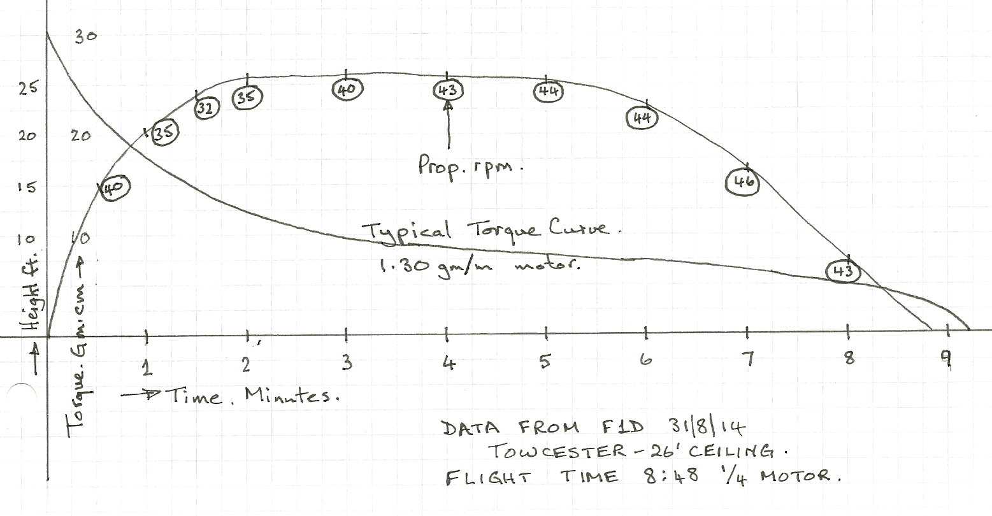

3.0 Advanced VP techniques.
3.1 Orientation of Prop Hook on VP Assembly.
When hooking up the motor to the model for flight, is normal to hold the prop bearing and assembly with thumb and forefinger with the open end of the hook facing away from the motor stick. To do this, it is far easier if the yoke holding the screws is on the other side ie. facing towards the stick otherwise there is danger of squashing the yoke, particularly if you have large hands!
If, with some assemblies as received, the yoke is on the same side as the open end of the hook, it is strongly advisable to turn the drive arm and shaft round so that they are on opposite sides. To do this, remove the retaining tube at the front of the hub and unhook the preload spring from the drive arm and preload screw.
Withdraw the shaft and drive arm to clear the pins, rotate through 180 deg and slide the shaft back, engaging both pins. If you need to replace the retaining tube, insulation from 1 amp electrical wire does the job perfectly. A length of up to 1/16” suffices and can be retained with a drop of cement or medium cyano. Don’t use thin cyano; it will go everywhere you don’t want it. Make sure that the drive arm is lined up with the screws as described above. Now you can replace the preload spring, ensuring that it is located on the preload screw first.
A word of warning, when you rotate the drive arm it is likely that the drive arm geometry will change slightly which will upset your VP settings requiring a retrimming exercise.
BB Note: Drawing on top needs to be altered to reflect this!
3.2 Accurate torque Meter calibration.
The usual units for torque measurement, at least in Europe, are gram.centimetres (gm.cm). A simple means of doing this is to use a rod which can be attached to the rubber retaining hook on the meter and which is at right angles to the axis of rotation of the torque meter.
Weigh the rod and establish its CG position. To apply a known torque, fix the rod to the winding hook at a known distance from the CG as described above. Hold the torque meter in the hands and rotate it about its axis which must be horizontal until the rod is held horizontal, but at right angles to the meter axis. The torque is the product of the rod weight (gm) and the distance of its CG from the meter axis (cm). Compare this to the existing dial and make up a new one if necessary.

