Making up a rubber motor loop.
General Rubber thickness and weight.
Different makes or batches of rubber will be of different nominal thicknesses, ranging maybe from 0.035” to 0.045” (TAN II is normally 0.042”) and any given piece will almost certainly vary in thickness along its length. This means that describing rubber by its stripped width, eg. 0.055” means very little in absolute terms. The most accepted (UK duration) way of describing rubber is by defining its weight in grams per metre (g/m), this referring to its stripped weight before lubrication and break in. In this way an F1D motor will typically use between , say, 1.25 to 1.40 g/m rubber. An F1L 1.35 to 1.50 g/m and an F1R between 0.60 and 0.80 g/m depending on the model weight.
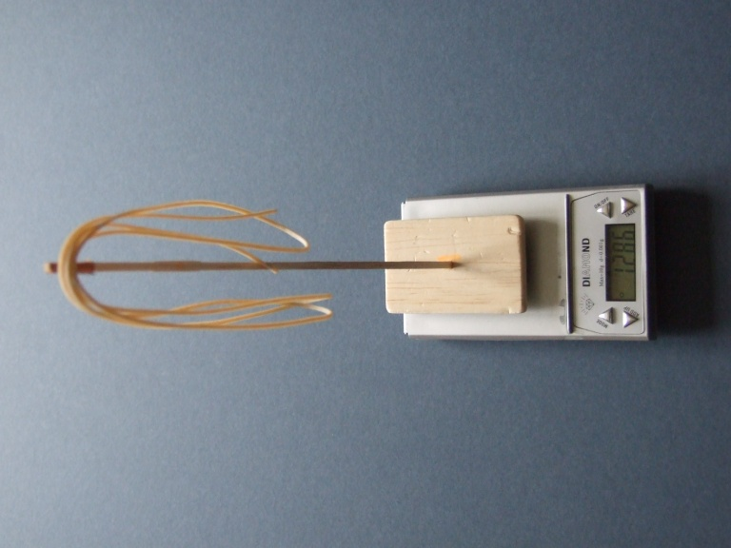
If you don’t have a rubber stripper and have to rely on strip bought by width then simply cut a metre off and weigh it – you really need mg scales for this and making up motors anyway. There’s several listed on the Amazon site from about £27. By the way freshly stripped rubber can have a lot of static which in close proximity affects these scales, make a base and a vertical arm about 9” long and suspend the rubber from this away from the scale. Also useful for suspending flying surfaces when weighing to minimise effects of air movement etc.

Weighing arm on scale + 1 metre of rubber

Target motor thickness and weight.
So the first task is to decide what g/m weight rubber you wish to use. The model plan or asking others will give a sensible start point and if in doubt use slightly heavier (say +5mg/m) rubber initially. Then strip your rubber into 1 metre lengths at or very close to your target weight.
Now you have to decide what the overall weight of the finished (full or partial) motor will be, simple if defined in the rules, eg. 0.6g for F1D, not so simple for open classes such as F1R, F1L - but 80 to 90% of airframe weight seems to be accepted as a good starting point.
As an example let’s say we’re making up a 1/3 F1D motor, target weight 200mg (In reality you’d aim for a couple of milligrams less to allow for residual lubricant after a competition flight). Cut the first piece a little long then trim to final weight, then cut as many motor strips as you need using this as a pattern BUT make each initially about 5mm longer than the original and trim to your target weight as you go.
You now have a bunch of motor strips all weighing pretty much 200mg, lay them alongside each other and you’ll notice that their length varies, sometimes considerably sometimes hardly at all. This is due to the variation in thickness (or density) along the length of the strip and means that in actuality the g/m target you so carefully decided varies for each motor. However this can also be an advantage because now we can measure the length of each motor and note it on the packet – I use small plastic zip bags which you can write on with a DVD marker. It may not be a lot but this does allow you to select thicker or thinner motors within fine limits depending on the conditions.
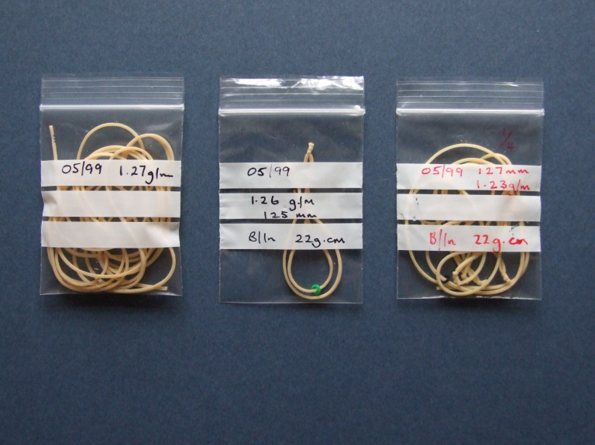
Note Rubber type, Full, 1/3, 1/4 etc. Loop length & weight

Knotting
Slip on 1 or 2 O-rings depending on partial or full motor, bring the 2 ends of the strip together and just barely lubricate the ends. Tie one overhand knot and pull tight then pull it out so less than 1/16” of rubber ends are showing, then tie another knot and pull up tight to the first one. If the knots slip out on stretching then remove more lube and try again, you can also buy anti slip powder which works well.
Running in
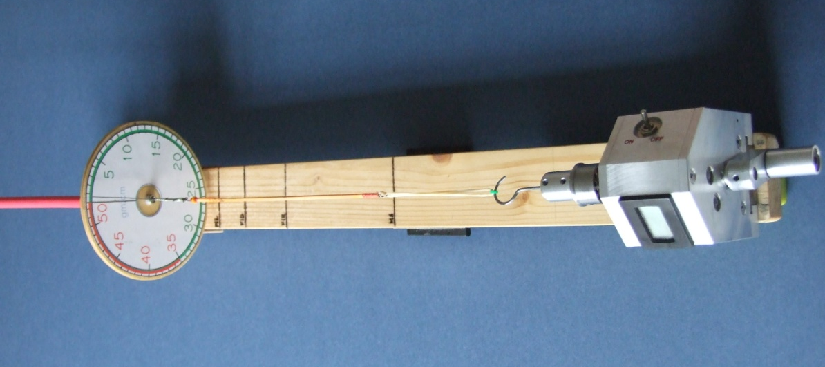
Lubricate the motor and set in your winding jig together with the appropriate spacer if using a partial motor. Stretch until really taut (ie. it won’t stretch much further), then wind until about half expected maximum torque is reached, then gradually come into the winding stooge whilst keeping the torque at this level (for F1D/F1L about 20 gm. cm. will be fine) leave the motor wound for 2 minutes or so. Unwind. I break in 6 motors or so at a time. Then you’re good to go flying.
Partial (1/4) motor being wound on stooge
“Competition” wind.
Winding rubber is a black art needing experience, practise and patience; experienced indoor flyers will have wound thousands of motors. There are several techniques in use, the one I describe is what I try to use! You will improve over time.
As a general rule if you want to get the maximum power from your rubber then you have to wind it hard and then back off the turns to a torque level that the model can handle with enough turns to achieve your target flight time.
Before you start to wind decide how many turns the motor should take and what torque you intend to launch on.
Eg. F1D on ¼ motor might be 450 turns and 27gm.cm of torque. Max torque may be 45gm.cm.
Check your motor for damage, any with nicks or signs of scuffing around the knot area should be discarded, a motor breaking on your model is often not a pretty sight!
All set? Right, put a little more lube on the motor then stretch until taut and put on half your expected turns. The torque should not go above half your expected maximum. Now slow down your rate of winding and gradually come into the winder dock keeping the torque as constant as possible.
Towards the end of this process the torque will start to increase rapidly, slow down further, now gradually wind towards your max. Torque. If you can’t get the target turns onto the motor, treat this as further break in, unwind and let the rubber rest.
Turns achieved? OK, dock the winder in your stooge and now unwind the motor until you get to your target launch torque. Note the turns, torque and back off in your flight log. Load the motor onto the model – front hook first and fly.
When flying many partial motor flights it is a good idea to cycle 2 or 3 motors so they can have a quick rest – different coloured O-rings help keep track of things.

Tony Hebb Jan 2013

