Building Notes - 35 cm Entry level.
By Tony Hebb, Aug 2014.
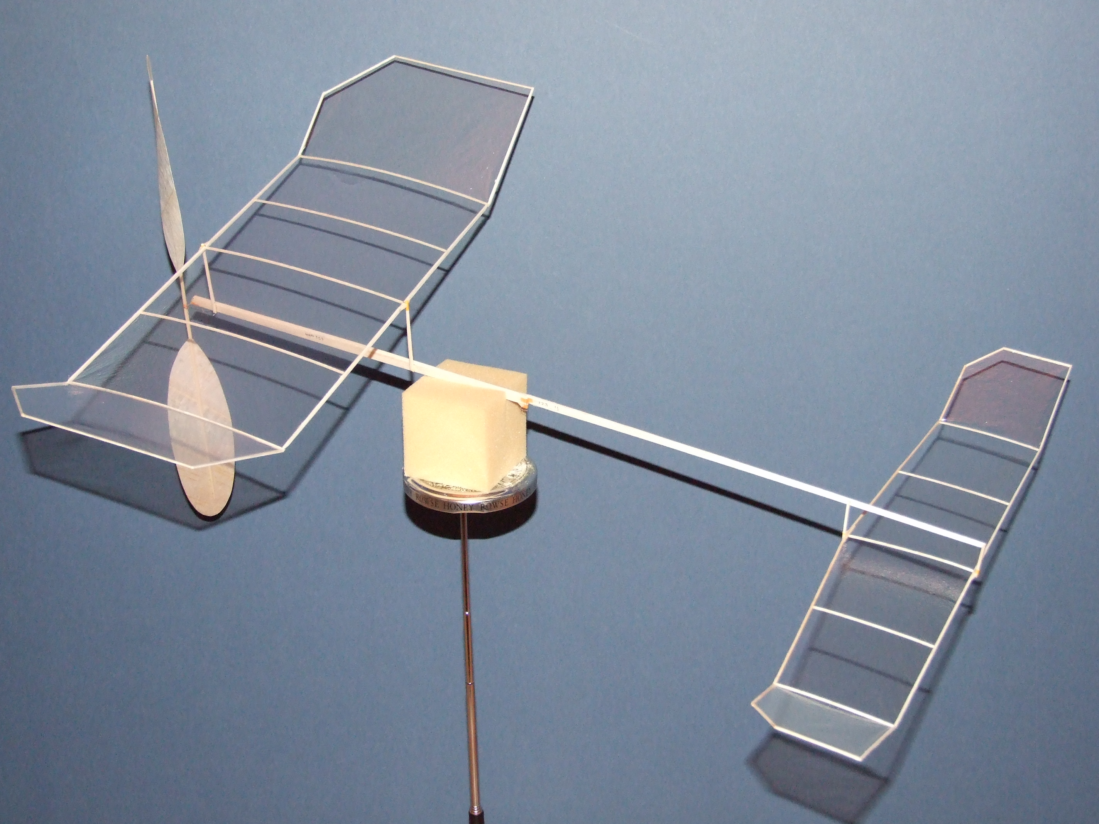The purpose of this model is to provide an introduction to indoor flying or a step on from, say, a Gyminnie Cricket that will provide excellent duration times whilst remaining easy to build. I say easy - but having built the prototype and tried to keep everything within the bounds of what a normal modeller will have available I realise that this is still not an easy task - but a challenge that can be accomplished, especially if you start with a kit and find a little local help. And hey, you can build this model without milligram scales, a digital thickness gauge or a sophisticated balsa stripper - you just need normal modelling tools and a good eye to start with.
Kits may be available from www.indoorbalsa.net, or e:mail Mark Benns at sales@indoorbalsa.net
As your confidence and skills grow you can build new, lighter components for your existing model whilst still remaining within a recognised duration class.
You will need the following tools:-
A metal straight edge, preferably 24”
Modelling knife with new blade
Carbon steel razor blades
Razor Plane, yep, with new blade please!
Pins
Balsa cement – ideally Ambroid or Duco thinned with 20% cellulose or acetone (I used nail polish remover for a while – well it was to hand, boom, boom!). If not available use UHU from the yellow and Black tubes, again thinned 50% with above.
Small round nosed and needle nosed pliers
Small side cutters
Fine sandpaper contact glued to a balsa block about 1.5” x 4”
From a material viewpoint you’ll also need:-
A “Dual” prop bearing (Harlan) for EZB model from SAMS or Flitehook.
.013” piano wire or .013” steel guitar string.
Film covering – Ultrafilm or Superultrafilm is fine. OS Film better but expensive for the amount you will use.
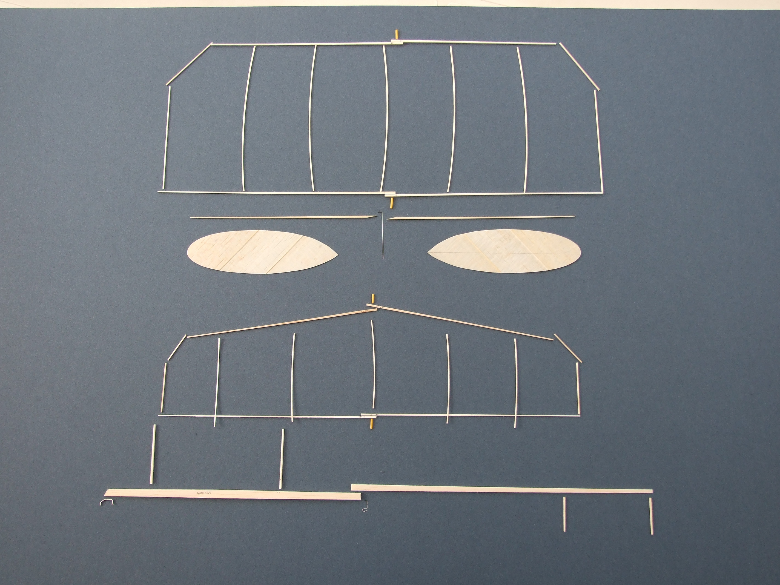Indoor quality 1/32, 1/16 (.063”)and 3/32 balsa, ideally in the 5 to 6 pound range.
Indoor .013” balsa for the prop blades, 4 to 5 pound C grain good - You might consider buying one of the EZB kits that are available and using the wood from it. Most indoor wood suppliers will operate a minimum order quantity for wood – this is where you need to get in touch with your local indoor community for a little help.
Build Notes.
First of all I am not trying to give a blow by blow construction account. Please, please find and read Larry Coslick’s Hobby Shopper EZB article (www.indoor newsandviews.files.wordpress.com – look for Best of INAV it’s in there) – he does this far better than I can and I still reference it today!
What I shall do is describe how to put this model together with as little fuss as possible and still get a decent duration model out of the other end – though I should warn that you will not use these construction techniques much in your indoor future!
Wing and Tailplane.
Measurements – 1/16 sheet is .063” thick, make 2 reference strips, one half this (.030”) thickness and one 3/4 (.045”) just by eye is quite good enough for now. These will allow you to gauge the finished ribs and spar thicknesses quite well.
Put a new blade in your razor plane and adjust it so that it takes the thinnest continuous shaving possible.
For the wing spars cut a piece of 1/16 sheet about 8” long by 1” wide. Mark a line across the top surface with a felt pen – lightly.
Take a shaving off the sheet starting at 2”from one tip, then repeat at 4” and finally 6”, just let the plane do the work, no pressing down, then lightly sand the sheet over its length to give a smooth taper to about .045” thick at the tip.
Cut 4 spars off the sheet using a metal straight edge, the razor blade and a good eye, cut the taper (from .063” at the root) by eye so the spar is about .045” at the tip, pair up the spars and sand to match along the length. Best to straighten up the edge of the spar sheet after each pair of spars to keep the grain running along the spar. Cut diagonal joints at the centre, pre glue then cement together, press against a straight edge to keep the bottom flat.
To make the curved ribs cut a template from stiff card, you can sand it smooth and if necessary a little superglue will harden up the edge. Break a razor blade in two and put some tape across the broken edge to hold it by. Use your .045” measure and a good eye to slice off 5 ribs from the 1/32 sheet. Use any deeper ones at the centre and dihedral joints, thinner ones in the centre.
Stick ¼” squares of sellotape over the plan where the glue joints fall, then pin pieces of straight edged balsa to outline the wing frame. Set the spars in position, holding them in place with soft balsa “clamps”, don’t pin the spars directly. You should pre glue all joints. I attach the ribs first at the leading edge, then cut to length using a NEW piece of razor blade and glue to the trailing edge.
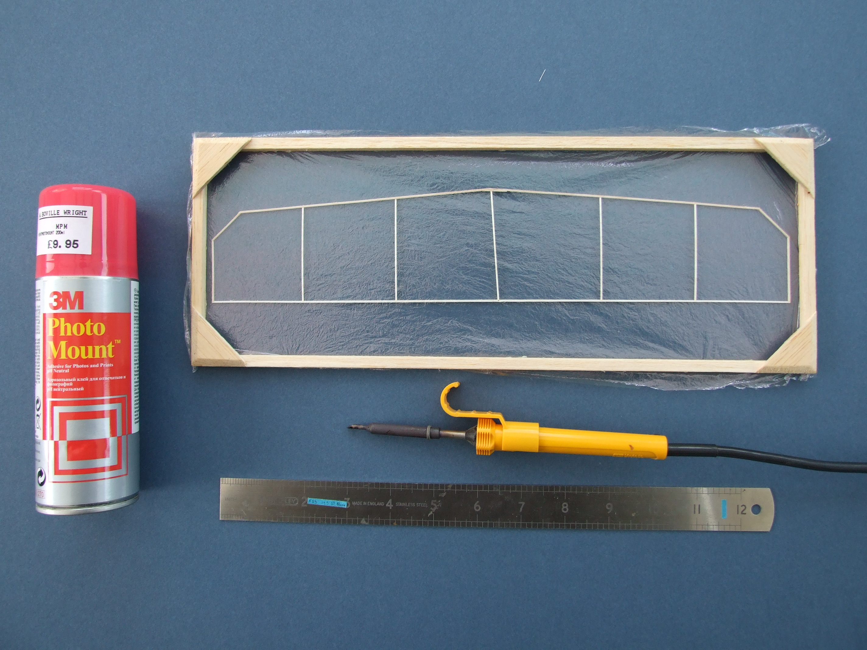The tailplane is the same, except of course the spars are thinner (taper from .045” square down to .030”) – the ribs can be a little thinner too. Note the offset on the centre rib.
Covering is OK with Pennyplane film or lighter (eg. OS film), advice comes with the film and there are various articles describing the techniques available on-line. It’s really not that difficult and so much better than condenser paper.

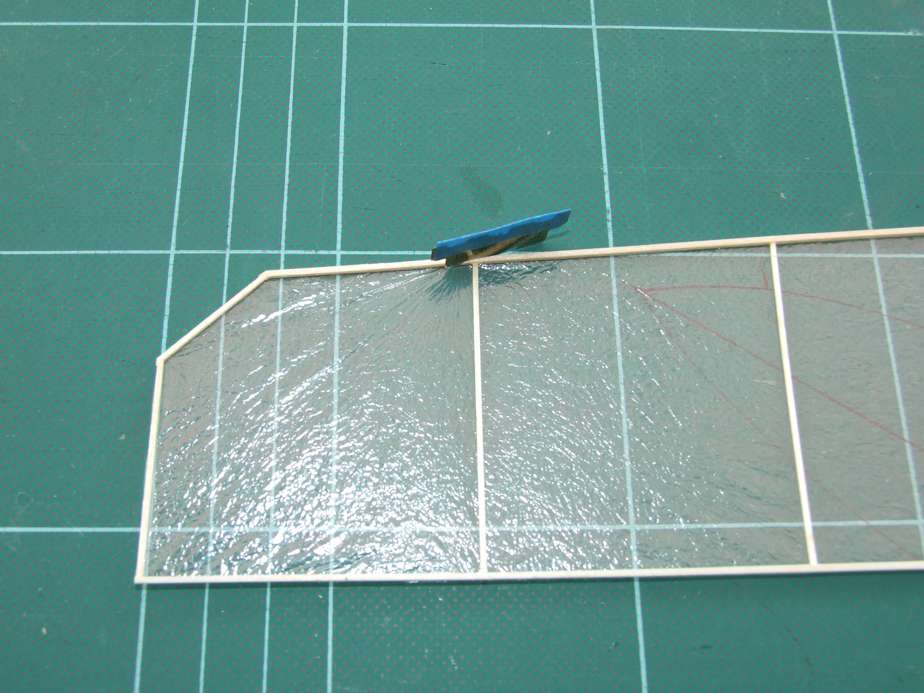
Finally cut the spars as shown at the dihedral breaks from the underside on the wing and tail, prop them up to the correct height and glue. Make a few “rugby post” jigs to help keep things flat, makes life easy and doesn’t take much making. See the indoorduration-gbr website for how to make them.
Motor Stick and boom.
Cut the ¼ wide MS from light, stiff 3/32 or 1/8 sheet, reduce the front and rear to 3/16 by taking a few shavings off with the razor plane, sand it smooth - go on - you can even round off the corners ever so lightly! Make the boom from 3/16 x 1/16 at the motor hook tapering to 1/8 x 1/32 at tailplane TE) – worth the effort though, this is an important piece of the model, needs to be as light and stiff as you can make it. Emphasis on the latter!
The wing posts are from good stiff 1/16 square balsa rounded (rotate gently between two pieces of sandpaper glued to a couple of flat pieces of balsa) – you only really need to round the ends. Make them a nice snug fit in the 1/16 internal diameter tissue tubes. These are just wraps of Japanese tissue about ¾ x 5/16 around some 1/16 wire glued up with ambroid. Something a little smaller diameter (about .045+) for the tail posts will be fine – I use a thick paper clip as a mandrel.
Glue the boom to the MS with a ¼” overlap joint; make sure it’s straight along the bottom edge.

Next add the front bearing with 2 to 3 degrees left thrust, 0 degrees downthrust, then add the rear motor hook. Add some Japanese tissue reinforcement wraps to both these metal to wood joints for security and full strength Ambroid.
To mount the posts I glue one in place first, then use the completed wing/tail to mark the location of the other. Finally put the tubes on the posts and with the wing propped up at the right height glue the tubes to the LE and TE spars. Make sure the wing/tail surfaces are flat at this point. When you glue the tail tubes in place build in about 3/8” tail tilt (port tip high) to help the left turn. Let the joints dry thoroughly before handling!
Propeller.
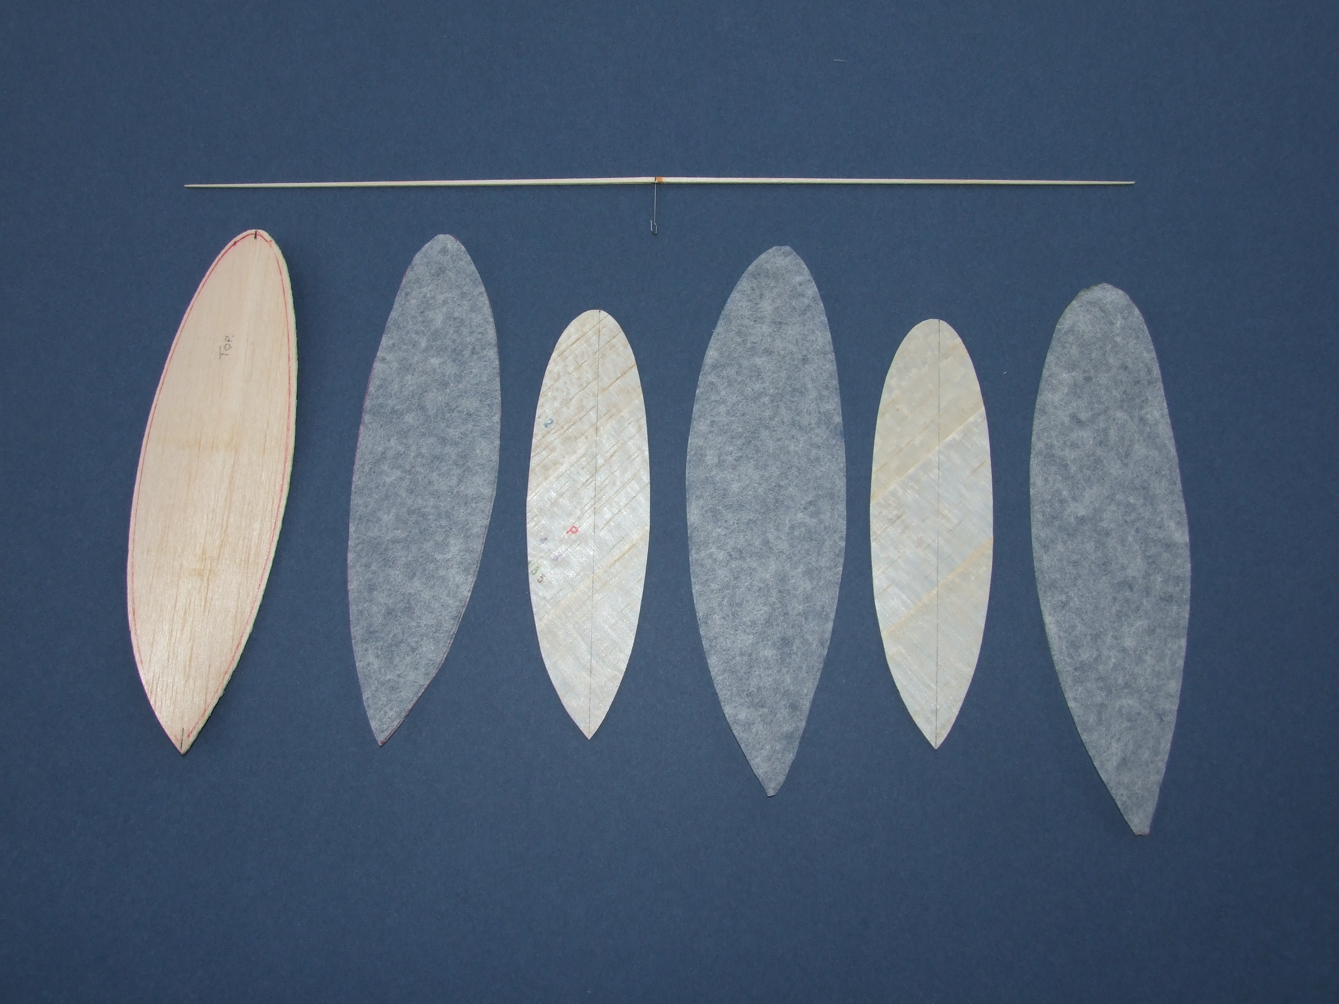Ideally buy some light .013” C grain sheet for the blades and make as per the Hobby Shopper article, otherwise its sand down from 1/32 – a bit of a task I know.
Form the blades wet over a bottle as per the Bob Bailey article for the Gyminnie Cricket on the BMFA web site – I’d recommend just a 10 degree offset and use a larger diameter bottle (than standard wine one!) for a former to avoid over cambering the blades. Using a proper pitch block is better but needs more work to produce, for this size prop. the bottle method is OK.
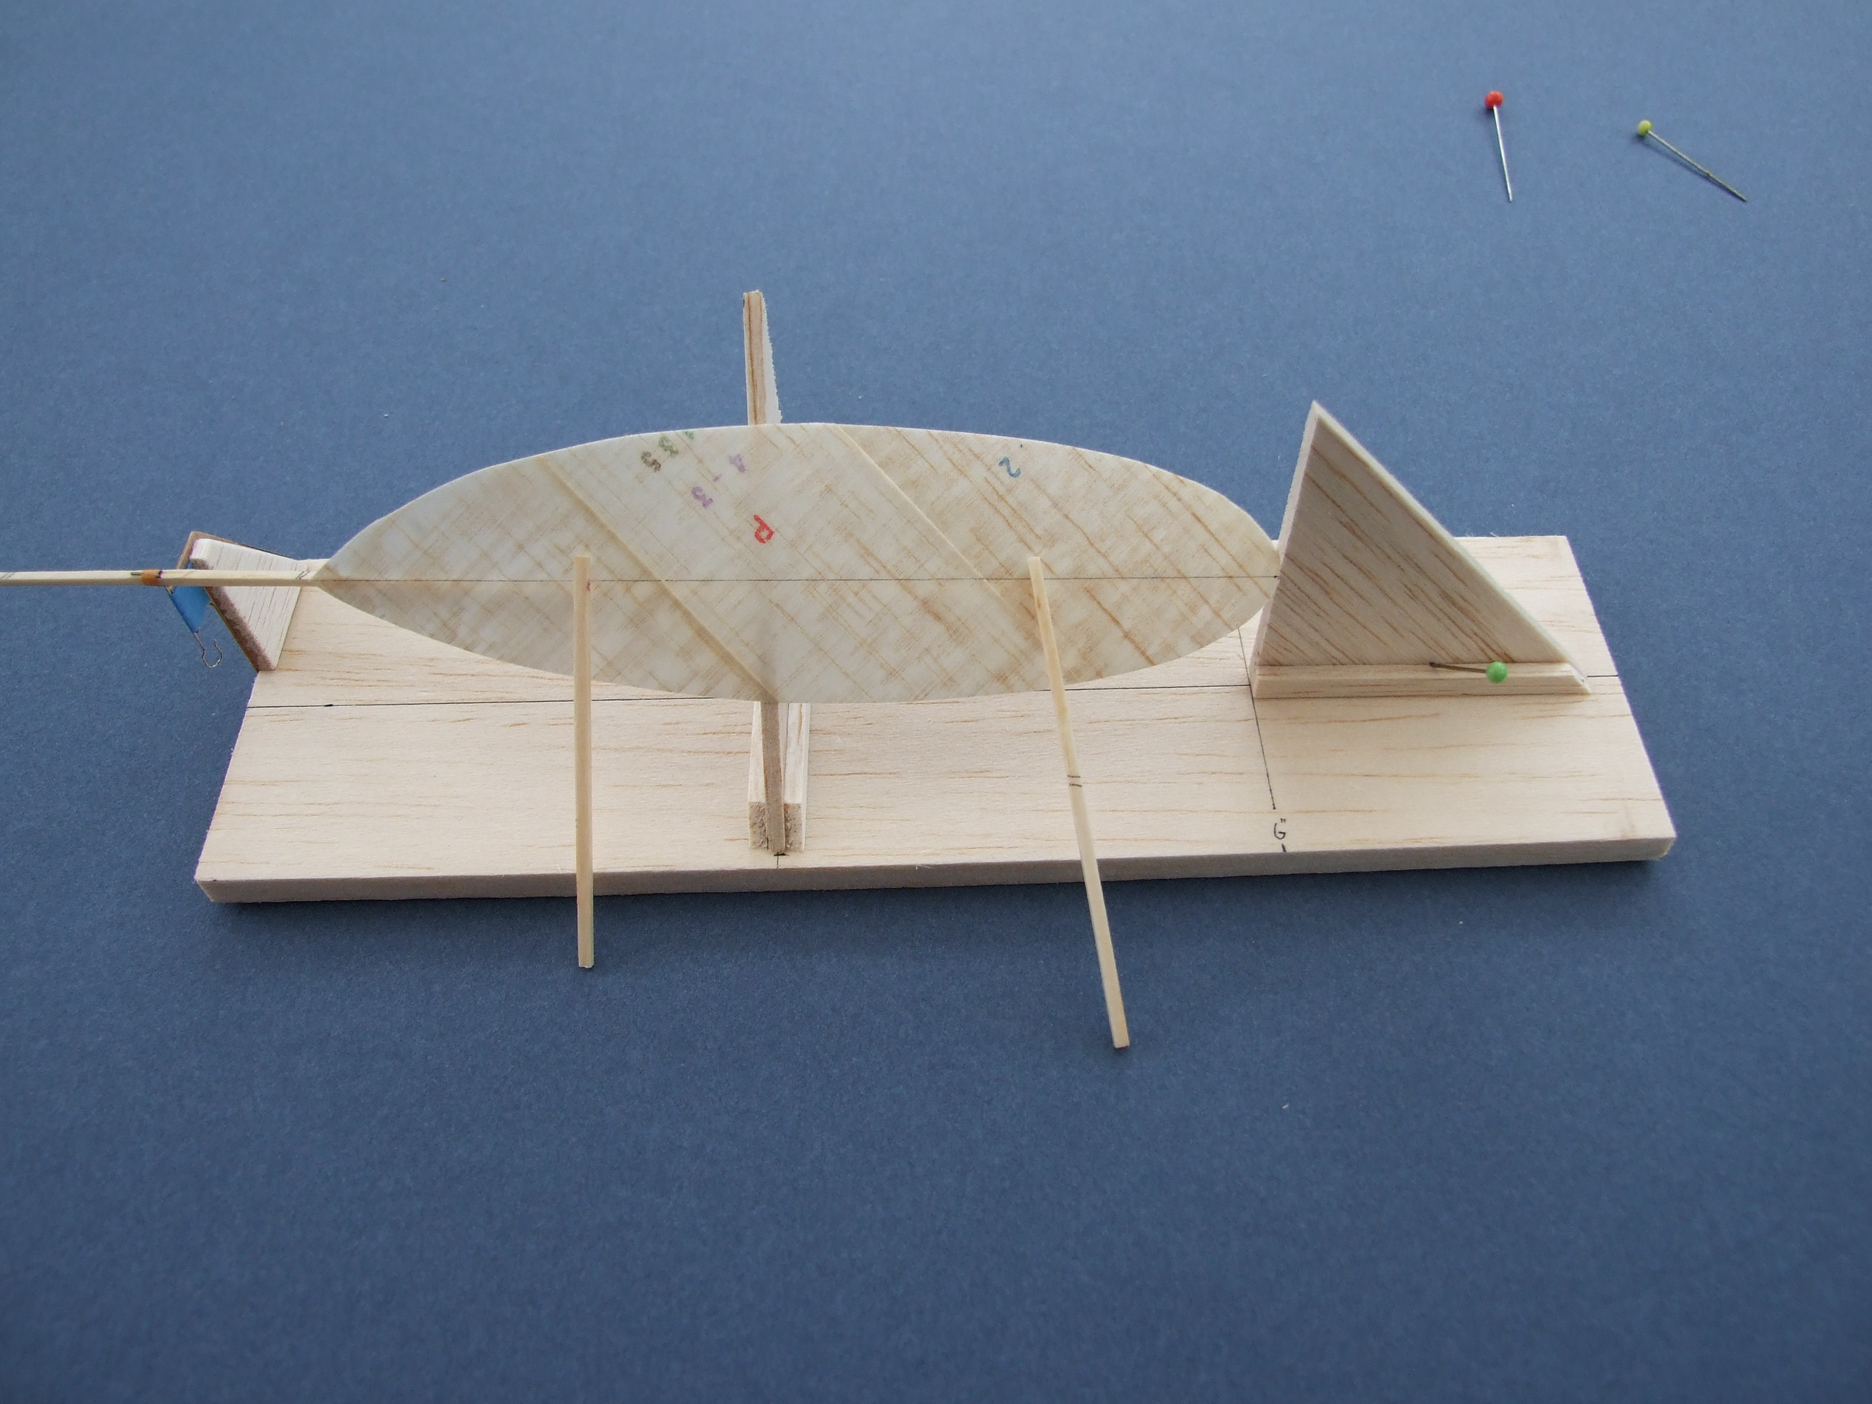Prop spar - use slightly harder balsa than for other components. Make two halves, tapering as for the wing spars to match them (.075” sq to .030” sq. At tip) and join at centre with scarf joint. Form prop hook, push shaft through spar at scarf joint and bend a U at the front end. Attach with cement or thin cyano, making sure shaft is at right angles to spar. Attach blades to spar using thinned aliphatic or white glue.
Prop pitch (20”) set by making tip angles about 28 - 30 degrees to shaft (make sure both are the same!).
The prop. is the heart of a duration model and time spent here will be well rewarded.
Flying.
This model is going to climb like a homesick angel, so for a typical sports hall and to speed up the trimming process I’d recommend using a 1/3 motor with a 2/3 spacer – make it from hard balsa or a bamboo skewer with 20g wire ends. See the indoorduration-gbr website for more information on partial motor flying. The size and weight of your motor (and therefore spacer) is going to be dependent on the finished weight of your model, my model weighs in at 1.25g and a full motor in the region of 900mg is OK. Try about .050” thick (about 1.2 gm/metre) rubber to start with. Hang the motor (+spacer if using) between the prop. and the rear hook and check that the model balances around the indicated CG, if not add blue tack or similar at the extremities to make it do so.
The wing is set at zero incidence and the tail at -2 or 3 degrees to start with. Put on a couple of hundred turns and try it, aim to fly nose up with a left turning circle of 15 to 20’ and enjoy.

Conclusion.
I hope that you’ll be able to get someone to help with the model as this makes all the difficult bits much simpler and they will have access to wood, rubber, scales etc. that makes everything so much easier. You can go it alone but eventually you have to fly the thing somewhere anyway, so why not get in touch up front?
Once you’ve made a model if you want to improve it there are many areas to try. It’ll probably be heavier than you’d like, now is the time to get fussier about weight and stiffness of the balsa you use. The spars can definitely be reduced, but remember it has to support the final weight of the model! Try to get a model built at around 1.0gm. The propeller blades can easily be made from .010” balsa or even try a built up propeller! Using OS film for covering will also save 50mg or so – I find this easier to use in fact as it seems to have less static charge. Or how about a rolled motor stick from .013” balsa?
All part of the challenge.....have fun!
Look forward to seeing yours fly, Tony

