Great Indoor Duration flying sites.
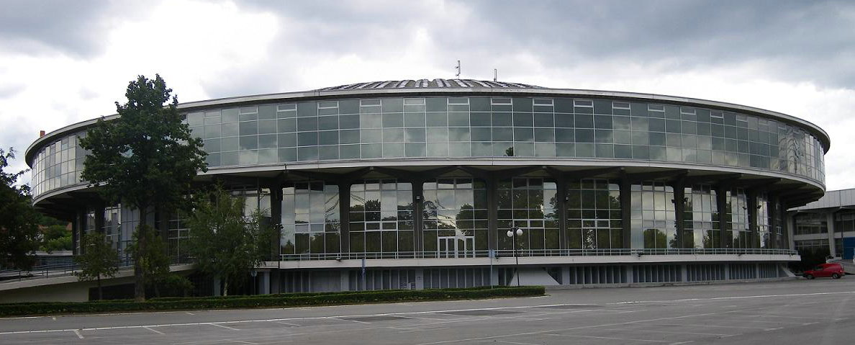
Belgrade Trade Fair Hall 1.
First impression of the Trade Centre hall interior is ……wow! It’s a very impressive 90’ high and probably 400’ across, a shallow concrete dome with circular roof lights running up the concrete ribs. There is a slightly oval central floor area surrounded by a raised floor about 5’ high., in fact I suppose being a commercial venue it all seemed very welcoming - if strangely empty. Around the perimeter wall there are 2 levels of walkways at around 20 and 40 feet, which give great views of models in flight. In summer it does become extremely hot inside, perhaps 25 degrees even at 08:00. To avoid unwanted air movement the doors and windows are closed too. During the day temperatures reach 36 degrees – you don’t want to be in the sunshine at these times – but there is a lovely little cafe just a short walk away on the banks of the river Sava!!
Belgrade has been host to several Indoor Duration European and World Championships.
World Champs held in 2008 (USA), 2010 (USA), 2012 (USA)
Records posted:- 2012 a new CAT III world record 39:10secs by Lutz Schramm.
A great shot of the hall interior with helium steering balloons.
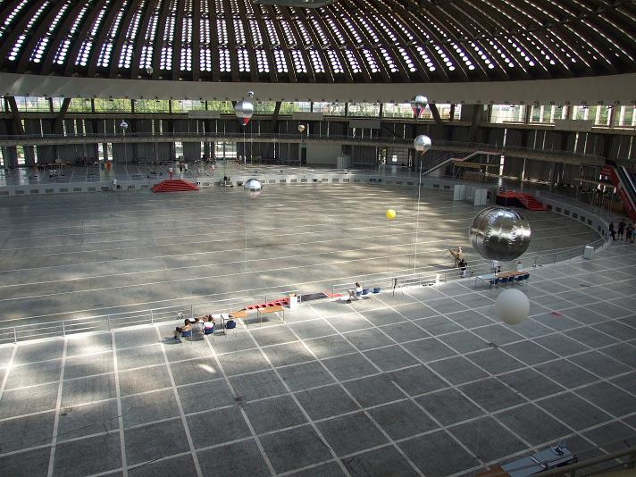
Just out of the above shot the dome has a flat roof which can be “scrubbed” by models – however danger lurks for those who wish to take this chance. There are many projections and bits of cable which can “hook” a model, there is almost always sideways drift at this height which will eventually push a model out onto the sloping concrete ribs and models will almost always lose height before a steering balloon can be brought to bear. The concrete ribs are also deeply recessed and any model unfortunate enough to enter is likely to be inaccessible.

A typical F1D flies slowly by in the sunlight.

