A TECHNICAL ANALYSIS OF RUBBER STRIP
By Carl Bakay, Indoor News and Views Editor
(Copies of this article may be distributed freely. Just credit the source.)

To start with a little background, I was working at Union Carbide Corporation in the 1960’s as an organic R&D chemist at their Silicones Division in Sistersville, West Virginia. Although it was not my assigned area, many of my friends were involved in the new field of synthetic silicone rubber, as were our counterparts at General Electric and Dow Chemical, now Dow Corning. The task was to find a way to make uniform batches of silicone gum feedstock, and use it to make silicone elastomers for demanding environments such as aircraft window and door seals, engine o-rings, and the like. You have seen the gum sold in a slightly doctored form as Silly Putty, and it is also spread on paper as a non-stick backing for peel-off postage stamps and address labels everywhere.

Well, as you might expect, not only did the silicone gum come out of the extruder in a wide range of viscosities, but when blended with fillers and catalysts, the resulting rubber it produced had properties all over the scale. One batch of rubber would be outstanding, and the next would have to be burned. No one could explain it. We liked to relate a similar tale of woe in the paper making industry. The paper mill once made an outstanding roll of card stock for IBM cards, and the foreman wanted to know if he should ship it. The quality control guy said no, destroy it, because IBM would want more of the same, and they could never make it that good again. Although my friends at Union Carbide worked on the problem for years, to this day, synthetic rubber manufacturing is more an art than a science. This is true even more so for natural rubber products.

FROM SAP TO STRIPS

We rubber fliers find ourselves in an even greater dilemma than the stories told above. Tan II is a natural rubber product that relies on tree sap as a raw starting ingredient. And as John Clapp said, like wine made from grapes, some years are better than others. As you will see, adding in the variable of manufacturing just compounds this problem (a little pun, that).

Most of today’s natural rubber comes from the sap of the Hevea tree, growing within 15 degrees of the equator. Its bark contains a milky fluid called latex, from the Latin lac, meaning milk. From the time the tree is six years old until it is about thirty-six, it can be counted on to produce about four to fifteen pounds of latex a year. As shown in the photos, this is collected from each tree in cups, and taken by truck to a processing plant. There it is mixed with acid causing it to curdle and separate into rubber and water.

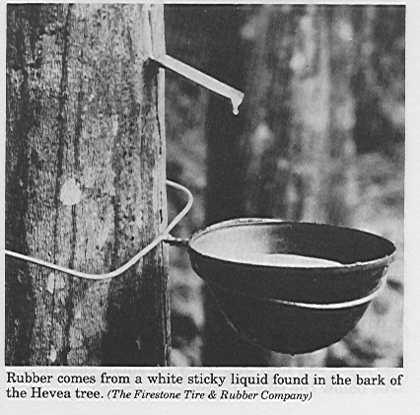 | 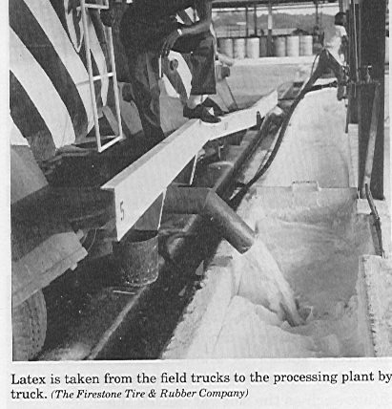
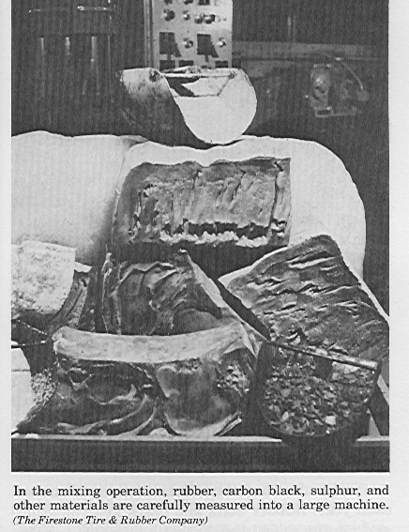 | 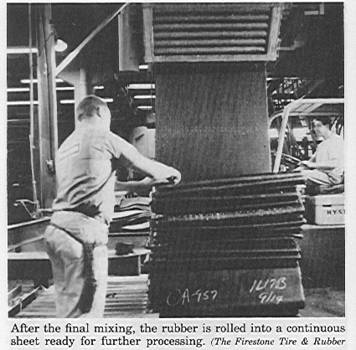
The Dry Process

This crude product is then squeezed, dried, and formed into bales for shipment all over the world. Most natural rubber products are made overseas in countries such as Taiwan and Malaysia. This puts the whole operation economically close to the equator where the hevea trees grow best. But when a bale of rubber is shipped to another country, it may have all manner of animal and plant contamination from the dock and the cargo hold. So first it is sliced into small pieces, washed and dried to get rid of impurities, and sent to a compounding room. Here, strips of crude rubber are fed through rollers which heat and soften it. As shown above, vulcanizing agents such as sulfur and charcoal, accelerators, pigments, fillers and antioxidants are added as specified by the laboratory.

It is now combined with about an equal amount of reclaimed or synthetic rubber, and fed into a Banbury mixer, which has grooved rollers and can do a better job of mixing than a smooth roller mill. At this point, it is still a crude, workable mixture, and what happens to it next depends on its end use. If it’s going to be made into rubber bands, the mix is fed through an extruder which forms a continuous rubber tube. I have visited one such domestic producer called Alliance Rubber in Hot Springs, Arkansas. The president, Richard Spencer, developed and patented a continuous extrusion process using a 460 degree salt bath curing system that produces rubber tubes of about 45 mils wall thickness in minutes. These are usually chopped into rubber bands of all kinds. But the continuous tube is very high in quality and made from 100% latex with little or no filler, and can be slit into a sheet and then strips for model airplane use.

For more conventional rubber strip, the slabs are heated on a warming mill and passed through a calender, which has a series of rollers adjusted to turn out a sheet of any thickness. For Tan II, it is calendered into sheets 0.021” thick, and two of these sheets are then pressed together and vulcanized to get a 0.042” thick finished rubber sheet. A more uniform product can be made in this way than by rolling one, thicker sheet. This is treated with talcum powder and fed through slitters to get ¹/₈” and ¼” Tan II rubber strip.

As far as size goes, this customer can testify that quality control is very good. FAI Supply says the thickness is 0.042 + 0.005”, and I’ve seen a range from 0.0415 to 0.0433 by measuring 6 to 8 strip stacks with a micrometer, which is considerably better than claimed. As for the width, my 1/8” strip samples are always exactly 0.125” with no discernible variation.

The Wet Process, or Look Out Tiger Woods

If the reader is looking for a good source of high quality indoor modeling rubber, already in the small sizes used by these flimsy creations, here is an idea. Cut open a Titleist brand golf ball of the 'DT' series, and inside you will find 18 to 25 yards of high quality elastic thread just under the cover. This is the same thread used in elastic underwear, socks, bathing suits and stretch pants, but of a much better quality. (Mostly because it has little or no cheapening filler). Let it 'rest' overnight in a cool place, tie some in a loop the next day, and you will put up some acceptable flights.

Rubber thread is made by something called the Wet Process. This means that, rather than starting with blocks of coagulated latex and dry additives, it starts with the latex still in solution as it comes from the tree. In a large vat, sulfur, zinc oxide, accelerators and pigments are added to the milky fluid and mixed thoroughly. The advantage here is that batches can be very large in volume and properties of the finished product held very constant. The disadvantage is that it is prohibitive to ship tanks of watery liquids any distance, so the manufacturing plant must be near the plantations to be cost effective.

Now the solution is allowed to run by gravity from little nozzles into an acid coagulating bath, where it hardens from a into thread, then it is water washed, dried, and steam oven cured continuously.

You see, there are two kinds of golf balls, and you will find this out for yourself if you cut open as many as I have. The solid-core ball preferred by Tiger and others has a hard polyurethane filling, often around a hard rubber center. This gives the ball great distance and predictability. In the other pocket of the golf bag are often the ‘wound’ balls, as they are called. They are springier and provide more hook and slice, if you have the skill and that is what you want. The rubber thread for the wound version can be made by slicing rubber sheet into strips, but is more economically and uniformly made by the wet process.

This thread is very tough and elastic, with energy storage similar to the Italian Pirelli rubber strip of the 1970’s (see the table at the end). This is because it is all natural rubber, with only about 1 to 5% filler, and is slow-cured in a steam oven. Two other advantages make it unique. With the large batch sizes possible in the wet process, the properties can be held very uniform. Also, the thread can be made as a composite, with a highly elastic soft rubber core, and a thin coating of tougher, oxidation-resistant material.

A HISTORY LESSON

Years before I was around, the earliest Comet ‘dime scale’ rubber model kits were put out in the 1930’s and were called that because they sold for either 10, 15 or 25 cents. For power, the instructions showed how to cut thin strips from an inner tube, and tie them together. During the Depression, this was a cost-effective way for a kid to obtain rubber strip.

Model Aircraft Labs, or MAL, in this country sold rubber in the 1930’s and 40’s with marginal energy. Some years later, J. H. Maxwell of Scotland was cutting balsa sheets specifically for indoor models, and was one of the first to offer rubber for them from a catalog in 1954, but the source and quality are not mentioned. One supplier in the 1950’s was Dunlop, with it’s T-56 product. Move ahead twenty years to the 1970’s. Now, there were two main sources of contest material available. One was Italian and called Filo Elastico, known in America by the more common name of Pirelli. The Italian product was originally sold as an elastic strip to tie up grape vines without damage, so the story goes, when it was discovered by modelers to have an excellent energy storage and release. But it was very prone to breakage on hot days in the hangar, and just about useless for outdoor flying in the 110 degree sun of the California desert. The other was a darkish stuff supplied by Ed Dolby called FAI Gray rubber, after the international aeronautical federation in Europe. The supply of both was as irregular as the quality. Pirelli could vary from 1800 to 3900 ft-lbs/lb, when one could get it, and the more available gray FAI from 2700 to 3600 ft-lbs/lb. The year 1981 saw the last of Pirelli shipped here, leaving only the FAI Gray.

Being a pro-active kind of guy, past NFFS president and champion indoor flier Tony Italiano went to his family homeland in 1985 on a fact-finding tour. He found at that time a Pirelli factory at Milan made the rubber sheet, and the stripping was done by Filati in a town called Gergamo. But the supply of rubber strip was an experimental affair, and the gentleman who had been making it had grown tired of risking hundreds of kilos of raw material on something that might turn out to be scrap. Since Tony took his trip, the gentleman has died, and the rubber has all but vanished.

Then, in June of 1993, Ed Dolby of FAI Supply introduced a new cream-colored product that took our hobby by storm, which some call Tan I. More stretchy and less prone to breakage than the dark gray FAI material, it had energies from 4200-4500 and set all sorts of new indoor records. Today’s competition Tan II rubber supplied by John Clapp, who took over the business from Ed, is now the only available, but still holds the high quality standards of the original material introduced in 1993.

THE CHEMICAL SIDE OF RUBBER

Natural rubber is a unique material. It is malleable and can be extruded and molded like a liquid, yet it is elastic and retains its shape like a solid. What modelers like is its ability to absorb energy in the form of stretching and twisting, and then give back most of that energy in returning to its original shape. (If it is of poor quality and loaded with fillers, it won’t spring back at all, and retains a “set”.) It is able to do this because rubber is a matrix of long polymer chains. “Poly” means many and “mer” means units, so these long chains are made up of many, repeating, units.

The monomer is called isoprene, and is made up of four carbon atoms, with what chemists call a “double bond” in the middle. On either side of this bond are two methyl, or CH₃, groups, large and bulky.

CH₃ CH₃ CH₃
\ / \ /
“Cis” Configuration C = C “Trans” Configuration C = C
/ \ / \
CH₃

As latex forms in the bark of the hevea tree, the monomer units join up to make a rubber polymer. The size of the molecules are determined during the growing season, and change from tree to tree. Since the double bond holds the two central carbon atoms rigidly in a plane, the methyl groups can either be on the same side of the rubber chain (cis), or on opposite sides of the rubber chain (trans) as it forms. So, aside from the molecule size, or molecular weight, the cis-trans ratio is determined at this time. This is because the molecule is never all of one or the other, but a mixture of the two configurations.

This is not so important to us while the latex is in a watery solution, and the long chains are just floating about in a dissolved state. But as the latex is coagulated, dried, rolled, and generally beat to death, the molecules fold into an ordered, elastic mass. If there are a high proportion of Cis units in the chains, the bulky methyl groups prevent folding, and the final vulcanized product will have one set of properties. If there are a higher proportion of Trans units, the chains are more flexible and can fold easily into a more ordered solid. This final product will have a different set of properties.

What is known at this point is that the “cis-trans ratio” in rubber is very important in determining, and eventually predicting, its properties. What is also known is that a more highly folded solid has the best elastic properties, but will crystallize more easily, and then break under high stress. This has been born out by experience with the best batches of Tan II. They would take many turns and store lots of energy, but had a tendency to shatter, often in flight, and destroy a model. Sport and scale fliers would not notice this, because they would wind to 70 or 80% of the breaking point. But the competition fliers going for maximum duration would wind to 95 or 98%, and do so only with great care.

THE ENGINEERING SIDE OF RUBBER

Engineers have long known of elasticity when measuring the strength of materials – it can be measured in the form of a stress-strain curve. An applied stress, or pulling, yields a resulting strain, or elongation or twisting. This is reversible, so all solids are elastic to a certain degree, until the stress exceeds the strength of the material, and it breaks. This is called the yield point. Vulcanized rubber is a tremendously strong material, but it doesn’t give much warning of its yield point - it just breaks.

As shown in the sketch at right, in its relaxed state, the chains are folded and entwined around each other. They are also crosslinked, or joined to other chains by linkages in the sulfur atoms formed during the vulcanization (or curing) step in manufacturing. But when stretched, the coils unwind and absorb energy. If kept lined up at the right temperature for too long, crystallization and breakage can occur. | 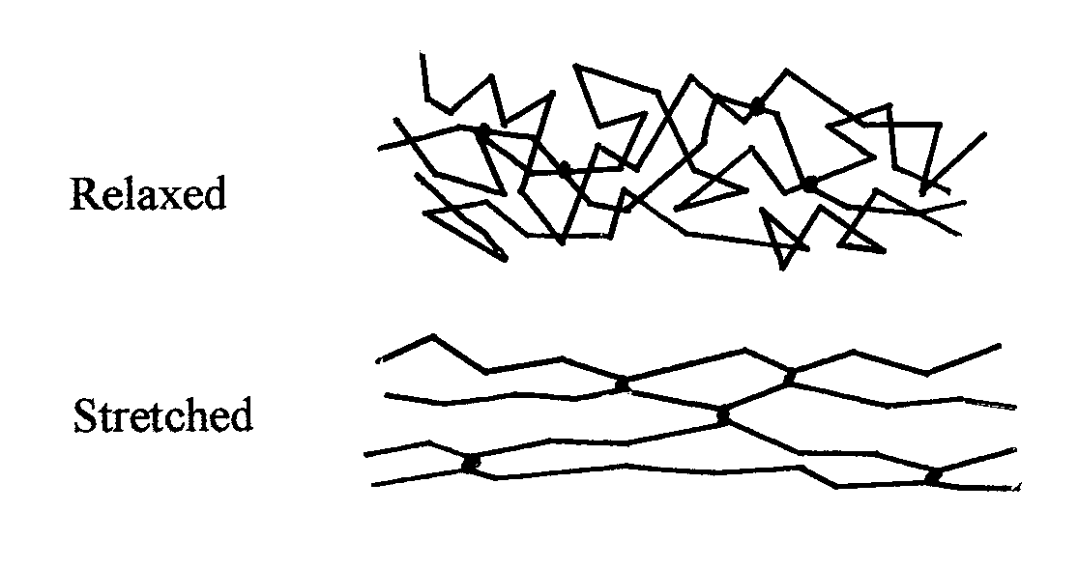

An important feature of a reversible stress-strain chart is that the stretching and relaxation curves don’t lie on top of each other. In other words, you never get out what you put in. This is due to hysteresis, a French word meaning ‘to fall short’. In the case of rubber, it is energy lost. Pull on a rubber band and press it to your skin; it will feel warm. This is stretch energy lost in the form of heat. Pull very hard on it and hold it for a long time, and it may turn brittle and snap. This is energy lost in forming brittle crystals and the failure of weak crosslinks in the rubber matrix.

We see an extra variable when using inexpensive rubber bands and other products. The chalk filler added to lower cost also has a tendency to ‘pop out’ of the matrix when stretched or when rubbed by the friction of knot formation, leaving weakened voids that won’t return to their original shape. So, in general, the less the fillers, the higher the natural rubber content, giving the least hysteresis loss, and the most energy.

FINDING THE ENERGY IN A RUBBER LOOP

All this leads us to the heart of this article, which is how and why rubber loops are tested for something called “total energy”, and what this means to the serious flier. The whole point of the introduction From Sap to Strip was to highlight all the variables inherent in making the box of rubber we buy and use. But, as a friend of mine asked, “Why all of this testing? Are we going to send it back?” No, I’m not, but I can accumulate many different batches, test them and see how others have tested them, and use the best to compete with and the rest for practice or sport flying. Also, Chilton and Tenny and Rash and Coslick will tell you that you have to wind a lot of samples and break a lot of motors to get good at it, and get the most from what you have. Testing is a way to speed up that process.

The hysteresis stretch-strain energy curve for a rubber loop drawn by John Clapp is shown below. It should be familiar to most readers. It is dimensionless, in that it doesn’t have actual numbers on the axes, but if it did, the best numbers to have would be 0 to 100% on both. That way all sizes and weights and batches can be drawn on the same plot, and only the differences between samples would show up.

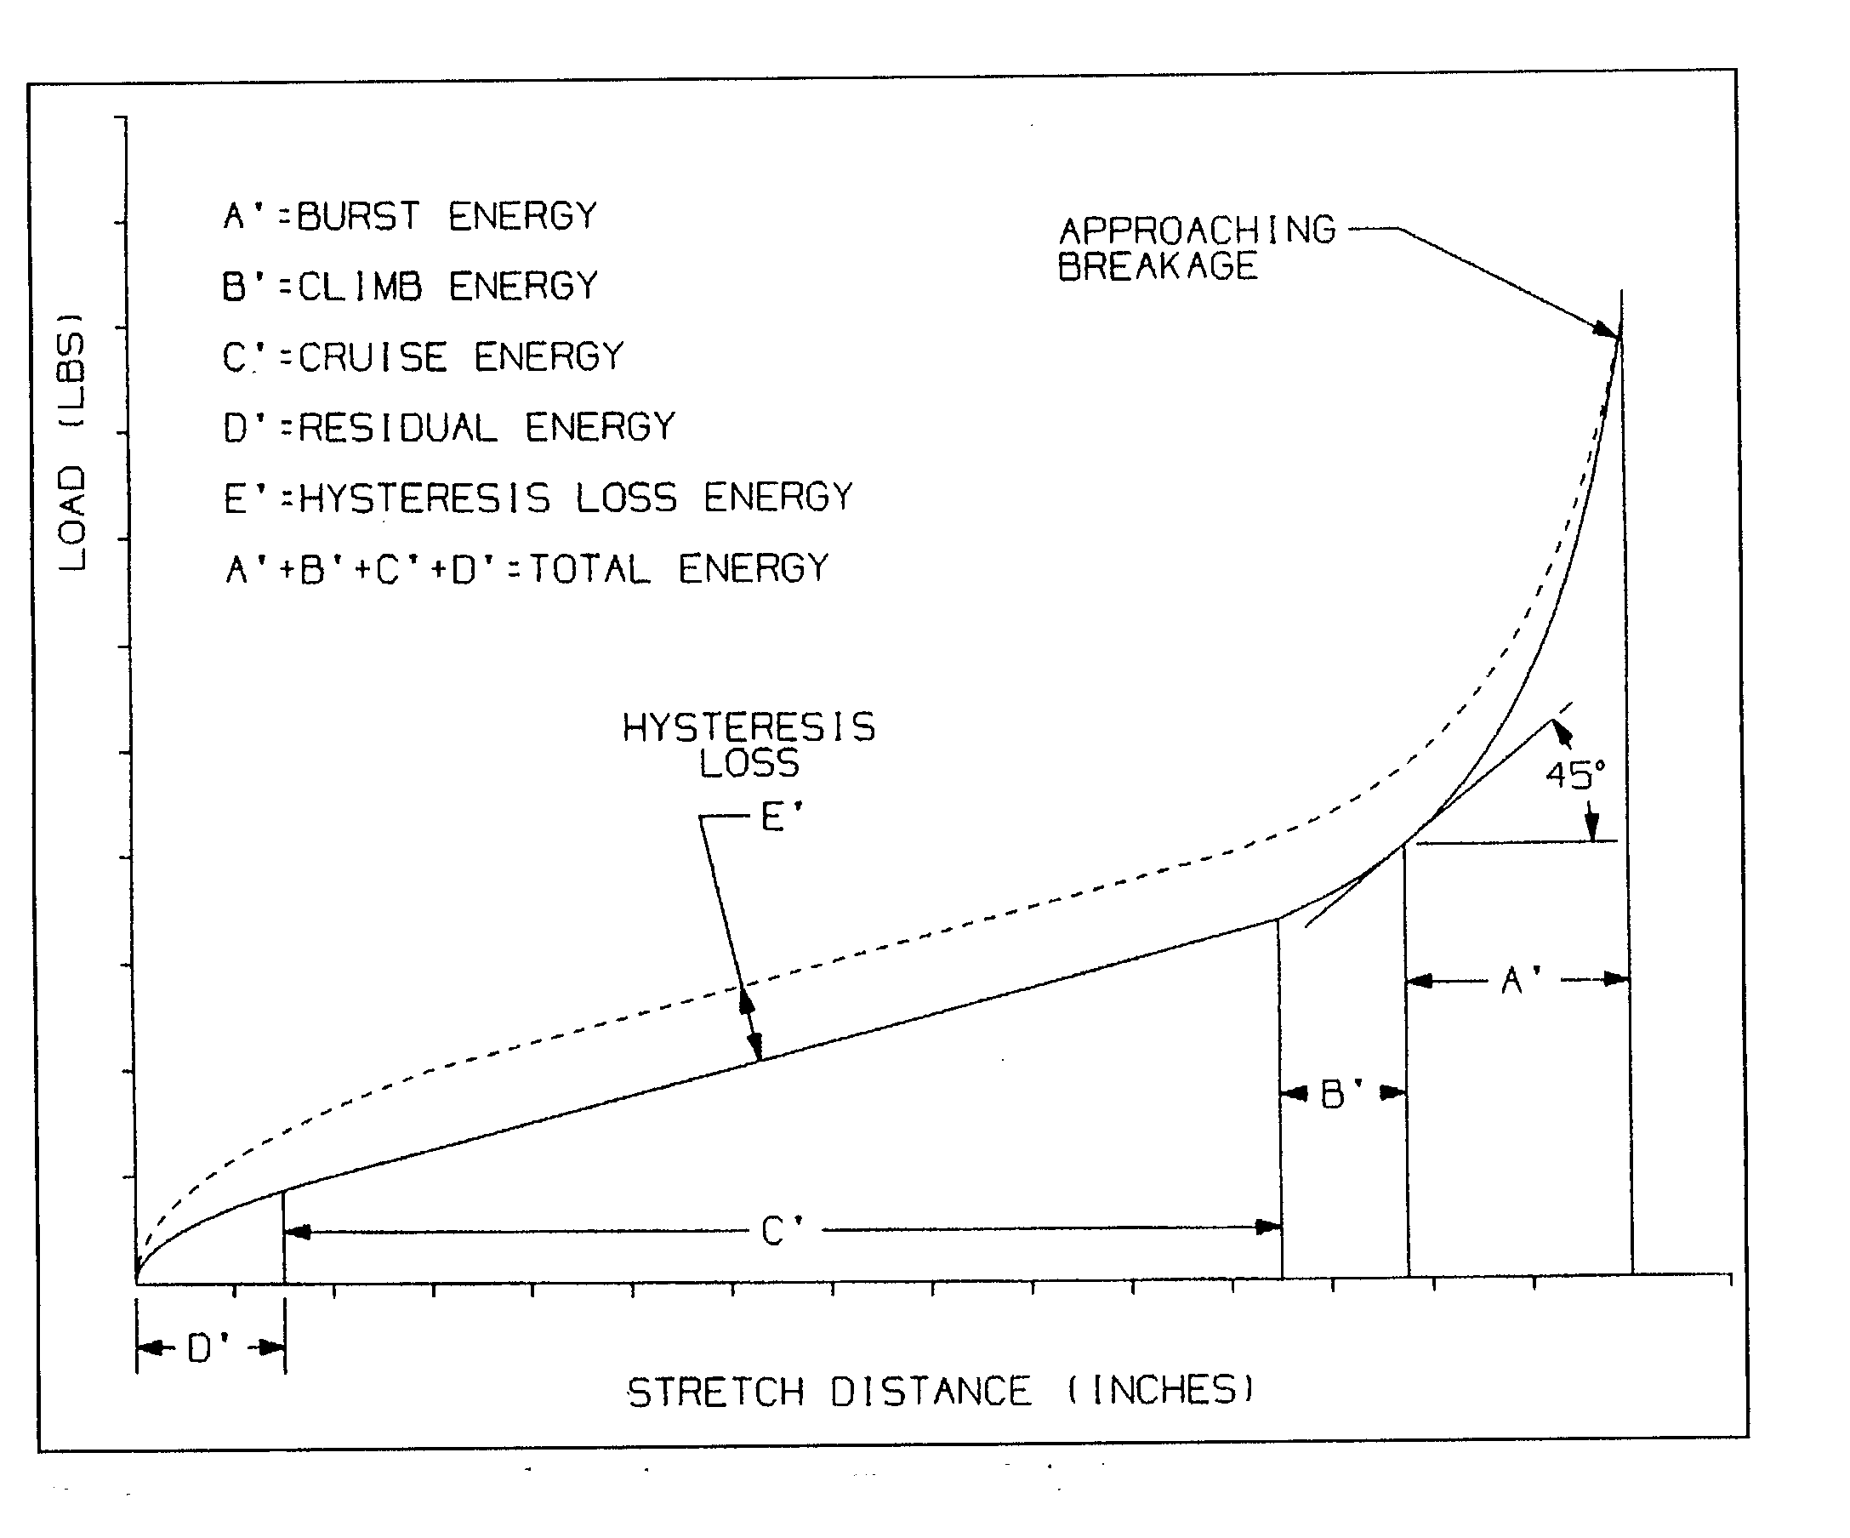
Whether we are winding or stretching, the first step is to make up 5 to 10 identical loops from the same batch, weigh them, break them in if desired, and wind or pull a few until they snap. This will establish the 100% point on the x (horizontal) axis. Then we record force in either pounds pull every 3 inches, or inch-ounces of torque every 100 turns, up until 95 to 98% of the breaking point, and then record the same increments while relaxing or unwinding the strip. The difference between the two curves is the hysteresis loss due to friction heat, broken links, filler and crystallization mentioned earlier. The area under the return (lower) curve is denoted by A + B + C + D, and is the total energy in the rubber sample. For flying, only
A + B + C are the useable energy, because the prop has stopped turning by the time the motor gets to D.

ENERGY FROM STRETCH TESTS

Let’s take stretch testing first. If we divide the return energy curve into slices, or bars to denote the sample size, the calculation method to find the area becomes obvious. Merely add up the pieces to get the whole. We add these bars together into one long strip of forces, three inches wide. The actual amounts of pull recorded during the test are noted on the graph below as F values. We first sum the forces by totaling up the average heights of all the rectangles under the return energy curve. The average value is simply the force on one side plus the force on the other divided by two. So the sum of the forces looks like

F = (Fmax + F1)/2 + (F1 + F2)/2 + (F2 + F3)/2 + .........,

But this can be simplified. If we multiply through by 1/2, we get

F = ½Fmax + ½F1 + ½F1 + ½F2 + ½F2 + ½F3 + ½F3 + ........,

and combining like forces, gives

F = ½Fmax + F1 + F2 + F3 + ....

F = ½Fmax + sum of all the remaining forces,

The last step is to convert to foot-pounds/pound, using ¼ to change the 3-inches to feet, and 16 to change the strip weight in ounces to pounds.

Energy = ¼ x 16 F / Wt of strip in oz. = 4F/Wt of strip in oz.

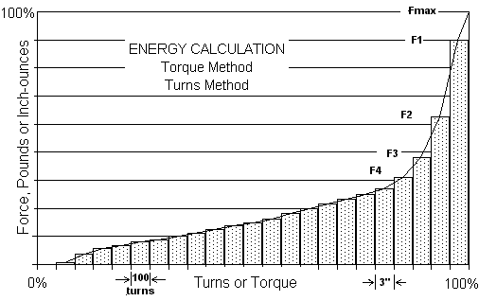

ENERGY FROM TORQUE TESTS

The good news is that we don’t have to go through the explanation of summing all the forces again, because finding the energy under a torque/turns curve is the same as for stretch. We are adding up strips that are T units high by 100 turns wide. Now we use T instead of F, so

T = ½Tmax + T1 + T2 + T3 + ....

T = ½Tmax + sum of all the remaining Torques.

We have angular energy being measured, so multiplying by 2¶ converts this to linear, there are 100 turns and 12 inch-pounds to the foot-pound, so the final equation needed is

E = 100 x 2¶ x T/ (12 x Loop wt in oz) = 52.35 x T / Loop wt. in oz.

The last question to be asked when talking about measuring rubber energy is, “How do these two methods compare, and are the results meaningful?” The answer is, “It depends.” Mathematically, the two analyses are the same, in that they accurately find the area under each curve, whether it be stretch or torque. But the following variables enter in to the test findings:

Are tests adjusted for the same temperature? The same humidity?
Are the samples from the same batch? The same box?
Were the loops broken-in before testing?
Was winding done by turns or by torque, slow or fast?
How close to the breaking point limit were the samples stressed?
Was a lubricant used?
Were enough samples tested to get a good average?

Without some examples, the usefulness of energy testing will be debated forever, but as backround for this article, the table of energies below was assembled. It not only includes stretch and winding results, but also rerun values that show that all samples benefit from a breaking-in of some sort. Readers are asked to search their files, and help INAV expand even further on this list.

RUBBER TEST ENERGIES – 1976 to 2001

Type Batch E @ 75º Source

FAI 2/76 3400-3500 Pearce 1979 NFFS Symposium
FAI 3/77 3200-3500 “
FAI 6/77 2700-3300 “
FAI 11/77 3050 “
FAI 9/78 3020 “
FAI 2/79 3350 “
FAI 6/79 3360 “
FAI 11/79 3290-3500 Pearce (rerun after two break-ins 3370-3600)
Pirelli 1978 3910 Cannizzo
Pirelli 1978 3680 Bob White
Pirelli 4/79 3500 Ed Dolby
Pirelli 6/79 3700 Ed Dolby
Pirelli 9/79 3430-3615 Ed Dolby (rerun after two break-ins 3600-3720)
FAI Tan 1991 3770-4100 Hunt, Indoor News #21, 1993
FAI Tan 1990 3050-3120 “

Type Batch E @ 70º Source
Tan I 11/91 3596 ft-lb/lb Rash RMPP
Tan II 6/93 3606-3654 Blackham
Tan II 8/93 3652-4409 Blackham WC batch
Tan II 5/94 3475 Rash RMPP
Tan II 6/94 4100+ Coslick INAV 82
Tan II 8/94 4100+ Coslick INAV 82
Tan II 4/95 3497 Tellier Spreadsheet
Tan II 1/96 4042 Tellier Spreadsheet
Tan II 4/96 4272 Tellier Spreadsheet
Tan II 6/96 4137 Tellier Spreadsheet
Tan II 7/97 3580 Rash RMPP
7/97 4140 Hunt. FF Indoor List, 8/25/99
Tan II 10/97 4513 Tellier, MAAC
Tan II 2/98 4485 Tellier, MAAC
Tan II 5/98 3861 Bakay (rerun 4042)
5/98 4325 Tellier, MAAC
Tan II 7/98 4390 Tellier, MAAC
7/98 3716 Bakay (rerun 3942)
Tan II 2/99 4582 Tellier, MAAC
Tan II 3/99 4198 Tellier, MAAC
Tan II 5/99 4110 Gibbs INAV 98
5/99 4675 Tellier, MAAC
Tan II 7/99 4093 Gibbs INAV 98
Tan II 7/99 4215 Bakay (rerun 4414)
Tan II 8/00 4307 Bakay (rerun 4345)
Tan II 9/00 4014 Bakay (rerun 4277)
Tan II 4/01 4351 Tellier, Cloudbusters Web Site
4/01 4172 Bakay (rerun 4327)(sample courtesy Tim Goldstein)
Tan II 6/01 4557 Tellier, Cloudbusters Web Site
6/01 4530 Bakay (rerun 4650)(my stock)
6/01 4523 Fitch (80ºF)

Rubber Bands 1780 Example of poor rubber, with high filler
Latex gloves 2600 Medium quality, some filler
Titleist Golf Ball 3185-3379 Rubber thread by the Wet Process
MORE ENERGY FROM GOOD HOUSEKEEPING

The engineering field in general is famous for giant pendulum swings in the way it does things. Years of reliance on technology eventually lead to disaster, after which comes a swing of the bob "back to basics." So it is with these motors - there are some basics that just seem to make good sense to turn into habits, regardless of the quality of the batch or event being flown, and how technical the user might be.

The first “basic” might be cleanliness, and the second, lubrication. Dirt and the resulting scratches are the enemy. Wash the entire box of new rubber in a mild soap and warm water, and rinse many times before drying. Only then should you apply a lubricant. But Bud Tenny said it better in his November 1997 column in Model Aviation.
"To obtain this kind of performance from any motor made from Tan (I or II), the rubber must be kept scrupulously clean. Tan II's surface is so smooth and slick that the tiniest piece of grit will score the surface. I find that consistent use of Armor All during winding, and while stabilizing the final phase of knots during the winding, seems to minimize scuffing between strands. Several fliers have reported scuffing with most versions of Tan II, but I can't remember scuffing, even under the hardest use, with Armor All and similar lubes."
It was only a few years ago that rubber lube did only that, lubricated the strands so they moved freely past one another during winding and knot formation. Just mix up Ivory or green soap, glycerine, lanolin, petroleum jelly and water, or buy the stuff ready made. But auto lovers have always known that rubber parts dry and crack too, and now there are products such as Armor All 2001 and STP's Son-of-a-Gun that not only lubricate because they are soapy silicone emulsions, but also protect against UV light and ozone degradation. Dow Corning and others make similar products. Whether it is best to apply it right after washing for its protective qualities, or wait until it is to be wound, is up to you. Some evidence has been accumulating that soaking motors in Son-of-a-Gun for long periods increases softness and elongation, to the detriment of performance.

A third 'basic' would be proper labeling, and storage of your stockpile in the refrigerator, just above freezing, in airtight, Ziplock Freezer Bags. Jim Bethea from Baton Rouge told me, "Keeping the rubber in the fridge will definitely help hold the original properties. The reason for this is that the activation energy for crosslinking is temperature dependent: hotter is faster and cooler is slower. I have been keeping mine in the fridge for 15 years." We might add that it is also dark in there, and that is good, too. But make certain the bags are polyethylene or PE, and not polyvinyl chloride or PVC, which gives off toxic fumes that will degrade the rubber and defeat the whole purpose of storage. How do you know which is which? Submerge the empty bag in water. PE floats; PVC sinks.

A fourth basic habit to get into is breaking in all your contest motors. Fred Pearce has many tests listed in the Table of Energies in this article, and he found that two hard break-ins increased energy storage by 2 to 4 percent. The author has found the same, on the order of 100 to 200 ft-lbs/lb improvement (after an overnight rest) from the first break-in, and 50 to 100 improvement after the second. Even office rubber bands and golf ball thread show this. Of course, cheaper formulas will hold a ‘set’ and never return to normal after a good pull, even if given a few days rest. But strips or thread made from all-natural latex rubber will. If you test your contest motors the night before in your motel room, you have accomplished three things: eliminated the loops prone to breakage before the contest, ranked your motors in order of performance, and broken them in, all at the same time. This kind of preparation is not a new idea, and is covered more in the last section.

The last basic habit may well be the best: keep good records. Buy some spiral notebooks or three-ring binders, and take them everywhere you fly. Study others and see what they do. Keep similar records as they do, and you will be able to compare notes one day. Then you will be standing on the shoulders of giants, and you will see a lot further.

BRINGING IT ALL TOGETHER

Some technical types I know are in love with data; lots and lots of data. But the real value comes when this is organized into information that the reader can use. Two modelers who have shown the way in turning energy testing into contest performance are Lt Col. Bob Randolph of F1D fame, and Wakefield flier Jim O’Reilly. In his short article in April 1993 INAV, Randolph states:
“Suddenly the idea hit me that what makes F1D so great is that everything is important. You need a good design, a well built model, a well adjusted model, good rubber, and capability to find the optimum motor to obtain really long flights. Any one factor that doesn’t measure up will reduce duration. Therefore you goal should be to improve all of the skills required. Some may question what skill has to do with rubber. The skill is in being able to identify which of the rubber you possess is the best and to keep an active lookout for better.”
Since 1983, Randolph as been using quarter motors in practice, and using his best quality, full motors for contest day. This way he stays with the best batch, and conserves what he has at the same time.
Jim O’Reilly has taken this a step further and has outlined a system of integrated testing and flying. This means that his stretch testing is done on actual contest motors, not samples from the box they came in, and this both breaks in and sorts the motors by specific energy. Although developed for outdoor, it is just as applicable to indoor competition.
- Make up motors to weight and length and put motors and labels in plastic bags.
- Lube motors and check their lubed weights.
- Conduct pull-type energy and break-in tests.
- Make a table of motors and their energies for the contest. Plan the best motors for early morning and flyoff rounds, with lesser motors for the warmer, thermal part of the day.
- Wind to torque values on the torque vs. length chart. Finish winding very slowly.
- Don’t be afraid to re-use a motor if it has no broken strands or nicks.

BIBLIOGRAPHY

Buehr, Walter: Rubber, Natural & Synthetic, William Morrow & Co., New York, 1964.
Clapp, John: Tan II Rubber: A Journey, 1999 NFFS Symposium, pp 85-88.
Coslick, Larry, Tan II, Indoor News & Views #77, July, 1994, p 4.
Gibbs, Bob: Rubber Testing, Indoor News & Views #98, pp 37-39.
Hunt, Bernard, to Tim Goldstein: private communications, 1999.
Hunt, Bernard, Rubber Testing, Indoor News, #21, Feb., 1993, p 10.
Hunt, Bernard, Posted on the Free Flight Mailing List, August 25, 1999.
Maxwell, J. H., Balsa for Indoor Models, published and distributed by the author.
Pearce, Fred: Energy Storage in Rubber, 1979 NFFS Symposium, pp 19-21.
Phillips, Hewitt: Generalized Energy Curves for Rubber Motors, NFFS Digest, Aug-Sept, 1985, pp 10-11.
Rash, Fred: Rubber Model Program Pack, (c) 1987-1998.
Tellier, Fred, Model Aviation Canada, Feb., 2000, Indoor Column.
Tenny, Bud, Free Flight Indoor Column, Model Aviation, Nov., 1997, p.120.

Referenced Patents:

Solid-Core Golf Ball – US 3,979,126, Warren Dusbiber to Acushnet Co., Sept 7, 1976.
Wet Process - Rubber Thread Production – US 5,804,307 and 5,679,196, John Wilhelm to North American Rubber Thread Co., Sept 8, 1998 and Oct 21, 1997.
Dry Process –Batch Steam Curing – US 2,781,550, William Spencer, Feb 19, 1957.
Extruded Salt Curing – US 3,787,552, Richard Spencer to Alliance Rubber Co., Jan 22, 1974

Photo Credits:
Cosner, Sharon: Inventions That Changed Our Lives: Rubber, Walker & Co., New York, 1986, pp 35-40

For further reading, copies of any of the reference materials will be furnished by the author, free of charge.
Just send a SASE listing the article(s) to: Carl Bakay, 1621 Lake Salvador Drive, Harvey, LA 70058

